

**MSc in Computing - Team Project**

**User Evaluation Report**

**Group 2 – SafePath**

*More than Navigation, Smarter, Safer journeys*

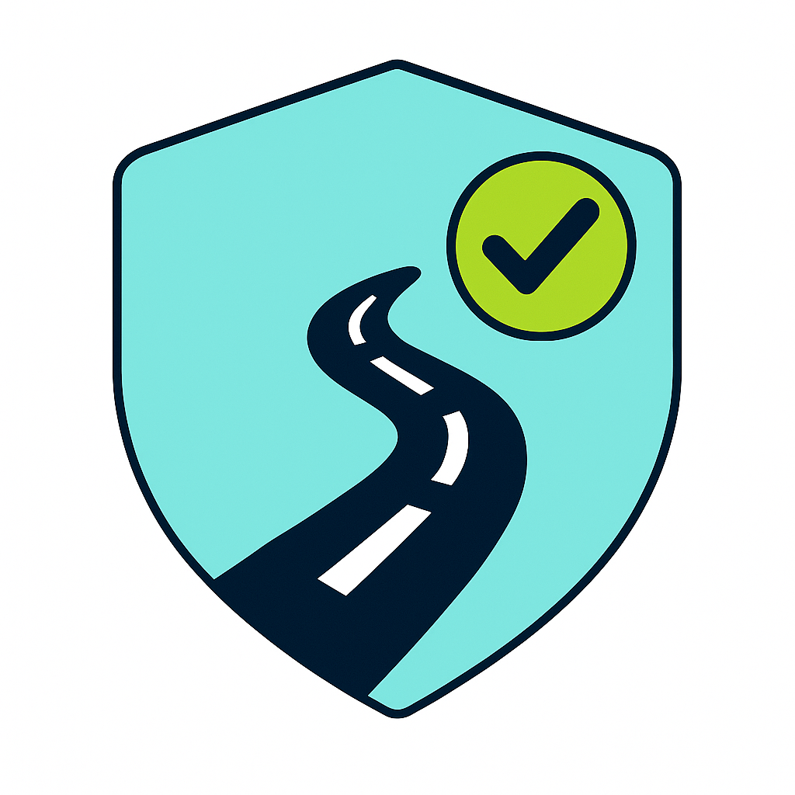

**Team Members**

D24126339 – Huda Ibrahim

D24127853 – Hina Kausar

D24126048 – Shalini Kuruguntla

D24125575 – Sai Priyanka Basa Shanker

D24125555 – Karan Joseph

**1/11/2025**

Table of Contents

Introduction 4

Phase 1 – Research Phase 4

Proposed Hypothesis 4

Competitive Analysis 5

Field Research 7

Participants 7

Cycling / Walking Experience 7

Main Findings Aligned to SafePath Goals 7

User Personas 8

Business Requirements 9

Functional Requirements 9

Non-Functional Requirements 10

Business Requirements Research Mapping 10

Concept Map 12

Phase 2 – Design & Implementation Phase 13

Low-Fidelity Concepts & Wireframes 13

Low Fidelity 13

Wireframes 16

Color Analysis & Theme Evolution 16

Logo Design 16

App Theme 16

Early Palette (Light / Pastel) 16

New Theme (dark / safety-first, single primary) 17

Expert Reviews (Mentors’ Weekly Critiques) 17

Concept and Branding Evolution 17

Architecture Review and Technical Decisions 17

Visual Theme and Color Evolution 18

Home Page & Navigation Structure 18

Suggested Routes: ML Concept to Rule-Based Safety Engine 18

Hazard Reporting: From Database Triggers to WebSocket’s 19

Authentication & Onboarding 19

Prototype Interviews 19

Overview 19

Design of the Interview 20

Data Collected (Context Data Table): 20

Contextual and demographic data were recorded for each participant to aid comparative analysis. Table 1 summaries the types of information collected. 20

Preliminary Results (Feedback Q1–Q10) 21

Analysis Approach 21

User Laws, UX Principles & Heuristic Evaluation 22

UX Principles 22

Key UX Laws Applied to SafePath 22

Heuristic Evaluation 23

Phase 3 – Final Application & User Evaluation 24

Evaluation Questions 24

Experimental Method 25

Overview 25

Tasks 25

Baseline and Comparison 25

Data Collection 26

Selected Subjects 26

Data Analysis 26

Practical Setup 26

Rationale for Chosen Evaluation Methods 27

Conclusions 27

References 27

Appendix 33

Demographic Survey Data 33

User Personas 38

Low-Fidelity Screens 40

Wireframe Screens 42

Initial Screens - Medium-Fidelity 43

Final Application 46

Color Analysis & Theme Evolution 48

Logo Design 48

UI User Research & Insights- Interview Questions 49

UI User Research Feedback 49

# Introduction

User evaluation is a core activity in the development of SafePath because the value of the app depends not only on the data or the routing logic, but on whether real walkers and cyclists understand that it is giving them a **safer** option, not just a **faster** one. Evaluating users lets us see where the current interface succeeds (e.g. showing hazards, safety labels, route explanations) and where it still causes confusion. It also helps us check the real context of use, people travelling at dusk, users worried about poorly lit streets, or cyclists wanting to avoid temporary hazards, rather than designing only from our assumptions (Interaction Design Foundation - IxDF, 2016; Nielsen, 1993).

User evaluation and usability testing can take several forms, from lightweight questionnaires on icon clarity to full task-based sessions where participants are asked to plan a safe route and “think aloud” while they do it. In SafePath we are using a mix of these methods(Lazar et al., 2017): we already ran a survey/questionnaire to get first impressions of the idea and the interface, we walked users through the app to see which screens or labels caused hesitation, and we are planning follow-up interviews to dig deeper into why they made certain choices (for example, why they didn’t pick the safer route). This gives us both kinds of evidence we need: the quantitative side (did they complete the task, how long did it take, did they pick the safer route) and the qualitative side (what they said about map clutter, the legend, wording, or how hazards are displayed). Combining the three survey, walkthrough, and interview helps us confirm patterns instead of relying on just one source.

In this report we first outline the user evaluation activities carried out on the SafePath prototype and why each method was chosen. We then describe the design of the experiment in detail the tasks, the participants, the data to be collected, and the analysis approach. After that, we present the results from the sessions, highlighting both numerical findings and user comments that point to design improvements. Finally, we provide a short conclusion that summaries what we learned about the current SafePath UX and what we would change or test again in a future iteration.

# Phase 1 – Research Phase

## Proposed Hypothesis

This project is a proof-of-concept focused on developing a safety-first routing app for cyclists and pedestrians in London, UK. The app will provide smart route suggestions that priorities personal safety by factoring in real-time and historical crime data. While the initial rollout targets London, future versions will expand to additional cities and countries. The app is shaped around the day-to-day experiences of cyclists and walkers. Later phases will also support city planners and transit authorities, offering insights to improve urban safety infrastructure. It also adapts to each user by learning from their preferences, routines, and risk levels, powering a personalized safety recommendation engine.

Before running usability tests, an exploratory survey was carried out to understand who our users are and what their safety pain points look like. That survey covered: core user types (age, gender, mode), safety issues they face (crime, lighting, crossings, infrastructure), features they value (safe-route choice, real-time alerts, hazard reporting, buddies), their trade-offs between safest and fastest routes, and the alert styles/frequencies they find acceptable. This evaluation now builds on that early data.

During the research and analysis phase for SafePath, we examined existing navigation and cycling/walking safety solutions to understand where they succeed and where users still struggle. This review highlighted several recurring issues that directly affect user experience, perceived safety, and overall trust in the system.

## Competitive Analysis

1. **Lack** **of safety-first explanations**

Google Maps usually presents 1–3 routes and says things like “similar time” or “fastest route,” but it doesn’t explain “this one is safer, better lit, fewer hazards.” The help page focuses on directions and time optimization, not safety justification(Google Maps Help, 2025b). Even large navigation apps have recognized that “fastest” isn’t always “safest.” Google Maps introduced a safer routing feature that tries to predict where drivers would have to brake suddenly and then choose a route that avoids those risky segments, Google said this could reduce up to 100 million sudden-braking events per year(Gaidarov, 2021). That shows the platform had to add extra safety intelligence on top of normal directions, However, the user interface still needs to explain to users why this path was chosen; otherwise, it will appear to be simply a faster side path.

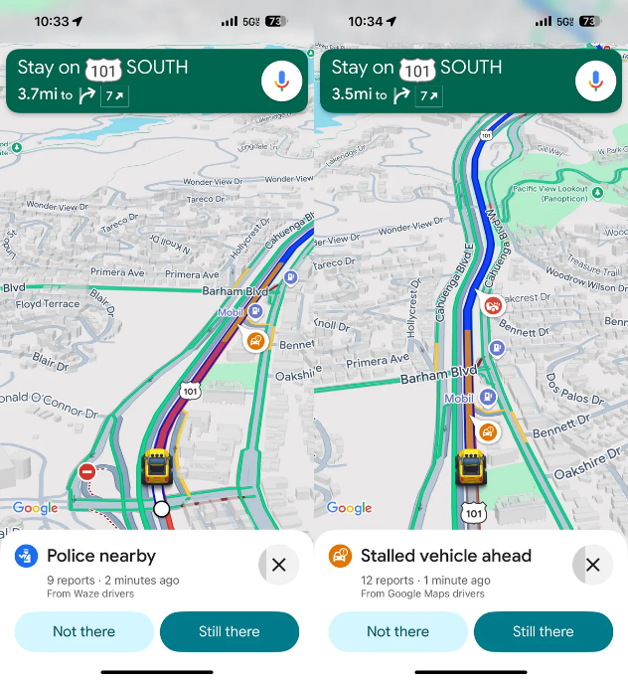

Figure 1 - Hazard Reports on Google Map

1. **Overloaded or unclear map layers**

When Google Maps started showing more incident info (partly from Waze), extra icons appeared on the map (police, closures, construction). Users can see them, but there’s no in-map legend, so meaning depends on prior knowledge. Google is even pulling in Waze reports now, which increases icon variety(Aguilar, 2025). If we show crime, lighting, and hazards at once without a legend, users will have the same “what does this icon mean?” experience as shown in Figure 1(Aguilar, 2025).

1. **Context mismatch (day vs night, cyclist vs pedestrian)**

Standard Google Maps directions can change by time (traffic) but don’t automatically switch to “safer at night” for walking, the help docs only talk about changing time to get better routes, not safety overlays. SafePath survey users specifically talked about evening travel and poorly lit streets, so we need to test safety comprehension in that context(Google Maps Help, 2025a).

1. **Weak / hidden user reporting flows**

Waze demonstrates a useful pattern for safety apps: reporting a hazard is a clear, named action, and they even introduced “Conversational Reporting” to make it faster, because they discovered that tapping through multiple menus was too heavy for real-time use. This shows that if the reporting flow is even slightly hidden or takes too many steps, users simply won’t submit reports(Popa, 2025). For SafePath, this is directly relevant our hazard-report feature must be visible and completable in less than 2 steps, or we will not get the fresh, on-the-ground safety data that our routes depend on.

1. **Route choice without safety context (CycleStreets)**

CycleStreets is very good at giving cyclists three route types: fastest, quietest, and a balanced option, and even considers hills, which is great for comfort. But it doesn’t usually explain why a route is “quietest” in terms of actual safety risks on that day (e.g. a new hazard, crime reports, poor lighting). It’s optimizing for cycling suitability from OSM data, not for incident-based safety in real time(Wikipedia contributors, 2025). SafePath can add that missing layer by saying: “This is safer now because there’s an active hazard on the other road.”

## Field Research

This phase of the evaluation gathered real user input to check whether the SafePath concept (a safety-first navigation app for cyclists and pedestrians) actually matches what potential users need in daily travel. Data was collected through an online survey and received **53 valid responses (all survey charts can be found in the appendix section)**.

### Participants

* **Total respondents:** **53**
* **Age groups:**
  + 35–44 years: **18** (largest group)
  + 25–34 years: **17**
  + 45–54 years: **6**
  + Under 18: **6**
  + 18–24 years: **5**
  + 55+ years: **1**  
    → Most respondents are in the **25–44** range, which aligns with commuting, school-run, and evening-travel scenarios where safety is more critical.
* **Gender:** almost evenly split (female 27, male 26), so findings are not skewed to one gender group.
* **Education / professional background:** respondents reported mixed higher-education and professional experience (students, employed professionals, and some with tech/transport backgrounds). This indicates the app is being considered by **regular city users**, not only by expert cyclists.

### Cycling / Walking Experience

* **Cycling experience:** a large portion of respondents identified as **beginner or intermediate** rather than expert. Only a small number reported advanced/daily cycling. This is important because SafePath should not assume high cycling confidence, it should support people who are willing to cycle but are held back by safety concerns.
* **Walking / mixed mobility:** many respondents also walk regularly as part of their daily routine (school run, short commutes, errands). That validates keeping SafePath usable for **both cycling and walking safety contexts**, not cycling only.

### Main Findings Aligned to SafePath Goals

1. **There is a clear gap in current navigation apps for safety data.**  
   Respondents said their main frustrations are: routes that don’t consider cycling safety, lack of information on bike lanes/lighting, and no info about safe parking. This directly supports SafePath’s goal to overlay **safety-relevant map layers** (crime, lighting, hazards, infrastructure).
2. **Users are willing to choose safer routes over faster routes.**  
   In the survey, most people said “safest” or “it depends” and only a very small number insisted on fastest only. That means SafePath can safely **prioritise safety scoring** in the UI, as long as the app explains why a route is chosen.
3. **Real-time or up-to-date information is highly valued.**  
   A large share said they would use the app to **report hazards** and also wanted to **receive alerts** (blocked path, low lighting, unsafe segment). This validates building a **crowdsourced hazard reporting flow** with 1–2 steps, exactly like we planned.
4. **People will contribute data if the flow is simple.**  
   Around three-quarters said they would report hazards/issues. That gives us a user base for generating fresh safety data, but only if the reporting action is obvious on the map, this supports putting “Report hazard” as a primary action.
5. **Supporting commuting scenarios is important.**  
   Because most respondents were 25–44 and not expert cyclists, the app should help with **everyday routes** (to work, college, childcare) and at **sensitive times** (evening, poorly lit areas). That matches SafePath’s core aim: reduce perceived and actual risk on daily urban trips.
6. **Extra safety features (parking, alerts, safer alternatives) are not “nice to have”, they are decision-making aids.**  
   Survey respondents mentioned bike parking and clear alerts, this justifies importance of this feature to added value for SafePath.

## User Personas

When we applied the SafePath app, the creation and use of personas became an important line of thinking as we transitioned from thinking like a designer to thinking like a real user. It is easy - especially the deeper you get into the design - to have to enter your own subjective, biased view of what users want and what features and functions are the most important. Personas require us to anchor the thinking and design to the real needs, goals and pain points for the users. To create the personas, we developed five of them based on the findings from a user survey which provided evidence, insight and understanding of real users' demographics, behaviors, needs and desires around safe navigation.

While still fictional in a sense, the personas were grounded in real data and understanding, not assumptions, which we felt contributed to their value as a design tool. They helped us to empathies with various users, from a solo walker to a daily cyclist, and assisted in prioritizing features and functions or resolving usability issues .

We grouped our personas into four primary types that represented patterns identified in the survey analysis **(all personas figures can be found in the appendix section)**:

* **Jayden Murphy – Beginner Cyclist:** Jayden represents new or hesitant cyclists who rely on technology for confidence and guidance. He values clear safety tips, beginner-friendly navigation, and reassurance when cycling in busy or unfamiliar streets .
* **Sarah O’Donnell – Casual Cyclist:** Sarah cycles for lifestyle and leisure, using it to explore cafés and markets. She values convenience, scenic routes, and calm, well-lit paths that feel enjoyable and safe for casual urban rides.
* **Alex Byrne – Expert Cyclist:** Alex is an experienced commuter who seeks efficiency without compromising safety. He appreciates data-driven route insights, performance tracking, and smart tools that balance speed with risk awareness.
* **Eliza Chen – Daily Walker:** Eliza represents older adult users who prioritise safety, comfort, and accessibility during daily walks. She values simple, intuitive design with clear navigation, good lighting information, and stable walking routes.
* **Daniel Murphy – Accessibility User (Wheelchair):** Daniel embodies users with mobility needs who require accurate accessibility data and smooth navigation experiences. He values reliable, clutter-free interfaces and inclusive design that ensures independence and equal participation

The five personas presented above capture the key segments of SafePath’s target audience from beginner and casual cyclists to expert riders, daily walkers, and users with accessibility needs. Together, they represent a balanced cross-section of urban mobility behavior and safety priorities.

## Business Requirements

After analyzing research findings, developing key user personas representing cyclists/ pedestrians of different experience levels and comparing SafePath's concept with existing navigation apps such as CycleStreets, Waze, and others, we defined a set of core requirements. These outline the essential features and design principles SafePath needs for building an effective, user-focused navigation app.

### Functional Requirements

* Users can search for walking or cycling routes.
* App provides fastest route suggestions.
* App provides safest route suggestions.
* Users can find a walking or cycling buddy going the same direction.
* Users can create an account (sign up) and log in.
* App can save user credentials securely for easier access.
* Users can report issues or incidents along routes.
* App can display secure bike parking locations near common destinations (markets, workplaces, etc.).
* Routes show nearby secure bike parking to help users plan safe parking options.
* Users can store preferences and bookmarks (e.g., avoid dark streets, prefer bike lanes).

### Non-Functional Requirements

* The user interface must be readable and inclusive, using clear fonts and high contrast colors.
* App must be easy to navigate to help users move safely without confusion.
* User data must be stored securely, in line with GDPR compliance.
* The app must scale to other cities, supporting long-term growth and wider use.
* The system should be reliable and respond quickly to user actions.
* The app should support cross-platform compatibility (iOS and Android).

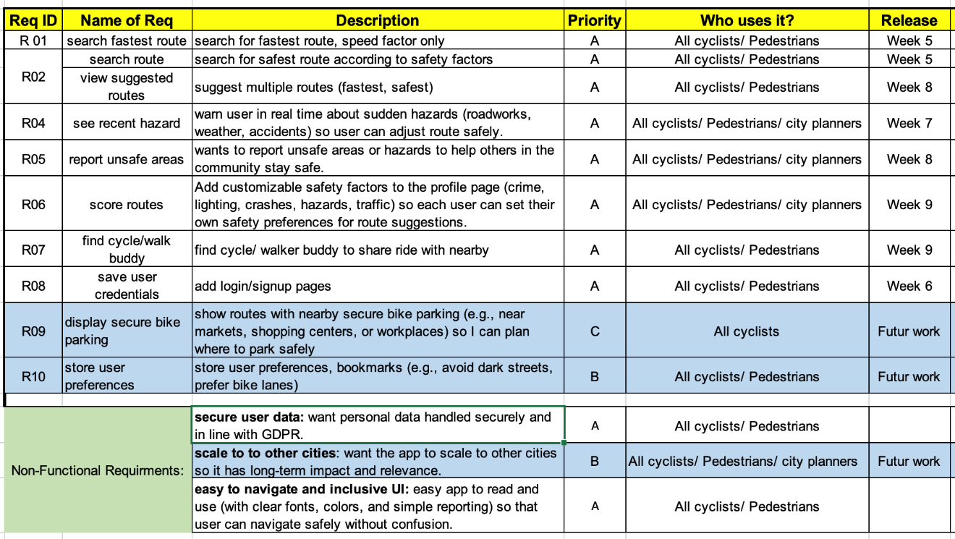

Table 1 - Functional & Non-Functional Requirements

### Business Requirements Research Mapping

| **Req. Description** | **User Survey Findings** | **Competitive Analysis Findings** | **Key Insight / Rationale** |
| --- | --- | --- | --- |
| Provide safety-first route options alongside fastest routes | **√** | Fastest mainly | Majority of survey participants (78%) prioritized *safety over speed*; existing apps (Google Maps, Komoot) focus mainly on distance/time |
| Display visual safety indicators (crime, lighting, hazards) on map | **√** | - | Users requested visibility of unsafe areas; none of the reviewed apps integrate official crime data or lighting overlays |
| Enable real-time hazard reporting and alerts | **√** | **√** | Survey showed strong interest in community reporting; few competitors offer real-time user alerts (e.g., Waze app) |
| Allow users to personalize safety preferences (e.g., weighting safety vs speed) | **√** | - | Over 60% of respondents wanted control over “how safe is safe enough.” No direct equivalent found in competitors. |
| Simplify navigation UI with clear, uncluttered design | **√** | **√** | Feedback indicated early screens were cluttered; Waze and Citymapper demonstrate cleaner home layouts and contextual menus. |
| Include community or buddy features for shared safety | **√** | **√** (partial) | Survey participants expressed strong interest in being able to share my journey with a trusted person. While few navigation apps offer full peer-safety modes, some competitors provide limited or related community features, for example: • Google Maps: “Share Trip Progress” allows live location sharing with selected contacts. • Life360 and bSafe focus on personal safety through real-time location tracking and emergency alerts between friends or family. • Waze includes community hazard reporting and road incident sharing. These examples show that SafePath’s “Find Buddy” feature aligns with existing market interest but integrates it more directly into cycling and walking safety contexts. |
| Generate route safety scores using open data (crime statistics) | - | √ (research prototypes, not mainstream apps) | Academic review identified several prototype systems that compute “safer” routes by overlaying official crime datasets on the street network (e.g., SafeRoute(Levy et al., 2020)). However, major commercial apps (Google Maps, Apple Maps, Waze) do not expose crime-based safety scores, highlighting an opportunity for SafePath to differentiate using transparent, data-driven safety scoring. |
| Support city planning insights through anonymised data sharing | - | √ (research prototypes, not mainstream apps) | Found in academic prototype, SafeRoute (Levy et al., 2020) but absent in consumer navigation tools |
| Provide multi-device access (web + mobile) | **√** | **√** | Respondents reported switching between devices; all major competitors support both. |
| Integrate real-time communication channel (WebSocket alerts) | - | **√** | Competitors with real-time alerts / live sharing - Waze: real-time incident & hazard alerts from drivers and partners; live map updates.  - Google Maps: real-time location sharing/trip progress to contacts (live updates while navigating).  - Strava (Beacon): live location sharing during activities; updates every 15 seconds.  - Life360: continuous, real-time family location sharing and safety alerts. |

Table 2 - Business Requirements Research Mapping

## Concept Map

Concept maps provide an effective way to display all essential development concepts for websites and applications. The tool enables you to visualize your goals and target audience while showing how different components relate to each other. The design process benefits from this cheat sheet because it helps you stay focused on essential elements. The process of creating the map are not structures, which will help generating innovative ideas which otherwise would not occur leading to improved user experiences for your product.

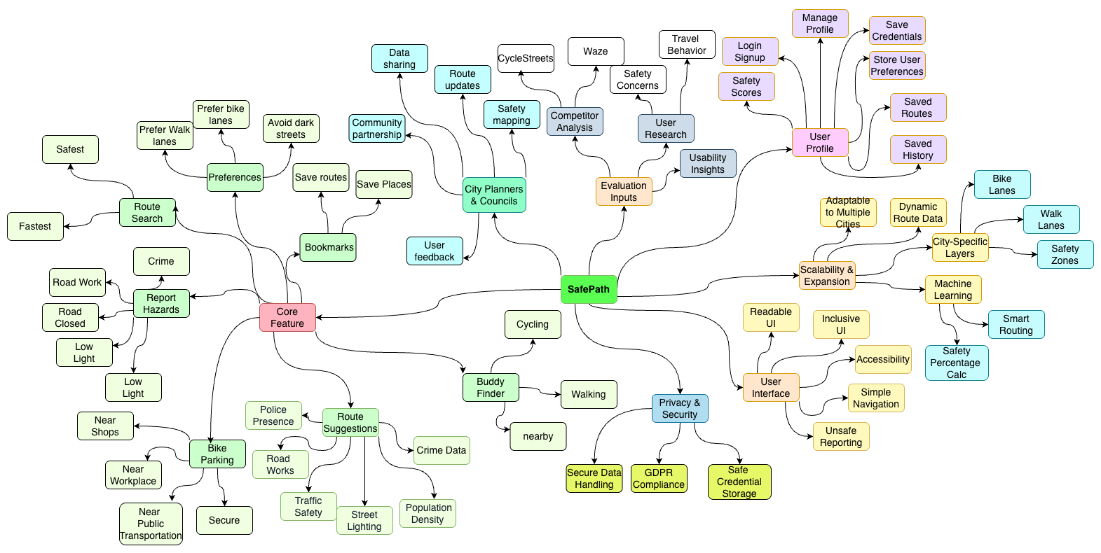

Figure 2 - SafePath Concept Map

# Phase 2 – Design & Implementation Phase

## ****Low-Fidelity Concepts & Wireframes****

### Low Fidelity

A low-fidelity prototype is a basic and simple version of a product or interface that focuses on the main structure and functions. It is used early in the design process to quickly test ideas and user flows. Low-fidelity prototypes help find problems, save time, and make sure the final product better meets user needs by testing and improving designs early(UXPin, 2024).

We will walk through the early-stage SafePath design screen by screen, and **the full set of low-fidelity sketches is included in the appendix**.

**Screen 1 – Landing Page**

* **Goal:** get the user quickly into planning a safe route without forcing full registration.
* **Elements:**
  + App name SafeCyclePath (early suggested name).
  + Big primary button: “**Plan my route”**, main flow.
  + Small secondary action: “**Sign in / Skip”**, idea is to let user try the app first, then sign in later.
* **Design Intent:** Get the user quickly into planning a safe route without forcing a decision about registration. At this early stage we weren’t sure whether SafePath should require sign-up/login or keep it completely open, so we sketched the landing page to support both options. The main action is the big “Plan my route” button, which takes the user straight to the core task. Below that, we added a smaller “Sign in / Skip” option to show that the app could later support accounts (to save routes, preferences, hazard history, etc.) but it shouldn’t block first-time use.

**Screen 2 -** **Plan Route (**early suggested name)

* **Goal:** Basic trip setup.
* **Elements:**
  + Back arrow to return to home.
  + “From” and “To” fields (with location pin icons).
  + **Toggle “find a mate”**, early naming of FindBuddy
  + Button: **“Generate current location”**, start navigation.
* **Design Intent:** This is the core trip-planning input screen. In later iterations we renamed it to **“Suggested Routes”** to better reflect the outcome of entering origin and destination. From here, the flow can be extended to pull in real-time data, apply the safety-scoring engine, or use saved locations. The early idea is riding safely with someone on the same route, but we later refined the label from **“find mate”** to **“Find Buddy,”** and the whole business logic was moved to its own dedicated screen so it could evolve as a separate feature without complicating the main trip-planning flow.

**Screen 3 - Route Comparison**

* **Goal:** let the user choose between **fastest** and **safest** visually.
* **Elements:**
  + Map showing the suggested path.
  + Bottom panel with two options: **Fastest** vs **Safest**.
  + Button: **“Choose faster”** (could change dynamically depending on selection).
* **Design Intent:** This was our early concept of how the app would display route options, showing the user a choice between a safer route and a faster route right after planning. Later, in the actual app development, we refined this flow: instead of a separate “choice” screen, we moved this logic into the “Suggested Routes” page. Now the user first selects “From” and “To”, then presses a “Suggested Routes” button, and the system generates routes based on the rule-based safety engine. That engine uses the user’s safety preferences (safety scoring) to decide which routes to priorities, rather than just a simple “safe vs fast” toggle**.**

**Screen 4 - User Safety Preference**

* **Goal:** give the user control over how “safe” the route should be.
* **Elements:**
  + **Safety slider**, move towards more safety or more efficiency.
  + Trip summary section**: time (12 min) + distance (2.6 km/m).**
  + Simple rating/stars for route quality.
  + Button: **“Start navigation”.**
* **Desing Intent:** This screen was the first version of what later became the User Safety Profile. In the low-fidelity stage it was per-route, simple, and manual, the user just adjusted safety for that trip. In the current version, we moved this logic into the profile page so that each user can have their own safety parameters saved in the database (e.g. crime 60%, lighting 20%, road condition 20%). These weights can be updated anytime, and the rule-based routing system will use them automatically when generating suggested routes for that specific user.

**Screen 5&6 – Report Hazards**

* **Goal:** Show real-time safety during navigation and capture what the user saw on the road.
* **Elements:**
  + **Map with current route.**
  + **Alert text like “Roadworks ahead - re-routing”.**
  + **Button: “Report hazard”.**
  + **Checklist of common hazards: pothole, broken streetlight, obstruction, other.**

**Design Intent**: Our first attempt to introduce the **community / real-time safety** part of SafePath, users help keep the map safe by reporting what they see. Originally, we separated it into two steps:

* **Screen 5:** Show real-time hazards on the map.
* **Screen 6:** Separate page where the user reports a hazard on the road.

Later, we simplified this flow. We merged both ideas into **one hazard page** whose main purpose is: **report a hazard and submit it quickly.** Using WebSocket’s, any submitted hazard is then shown instantly to all app users, so we still keep the real-time benefit but with a faster, lighter interaction for cyclists.

**Screen 7 – Find Mate** (early suggested name)

* **Goal:** Explore a social/safety add-on, where users can see nearby SafePath users and choose to ride or walk together.
* **Elements:**
  + Map with other nearby riders.
  + Fields like **Name** and **Start time** to send or accept a buddy request.
  + Actions such as **Request / Send**.
* **Design Intent:** We initially called this page “Find a Mate” but later renamed it to “Find Buddy” to better match the safety-friendly tone of the app. The core idea stays the same: using the user’s current location, the app can show nearby users within a small radius (e.g. 2–5 km) so they can coordinate a safe trip together. This feature is still exploratory and will need more UX and backend refinement, but the intention is to make riding/walking safer through presence, and to keep it **optional**. Users should be able to choose whether to share their location or just follow a friend’s location to meet up.

**Screen 8 – User Preferences / Privacy**

* **Goal:** Centralize the user’s account details and safety preferences in one place.
* **Elements:**
  + **Account info:** name, email, phone, profile picture.
  + **Safety scores:** saved weights for factors like crime, lighting, road condition, etc. (used automatically by the rule-based engine).
  + **Location sharing:** on/off controls (e.g., share with buddies, hide my location).
* **Design Intent:** Centralize all user account details and safety settings in one persistent Profile. Users can view and update their name, address, phone, and photo, and manage location-sharing with clear, opt-in controls (e.g., share with buddies, hide my location, time-limited share). Each user’s safety-scoring weights (e.g., crime, lighting, road condition) are saved in the database and automatically applied to Suggested Routes, so routing always reflects personal preferences. The result is privacy-respectful, user-friendly navigation that adapts to individual needs with fewer steps**.**

### Wireframes

A wireframe is a basic visual guide that defines the structure and layout of an interface, focusing on how elements are organized on the page. After finalising our low-fidelity prototype, we created wireframes to validate the flow and refine screen content. During this stage we identified UI issues, removed unnecessary screens, and consolidated overlapping interactions.

We simplified the experience to four core functions which corresponds to the value suggested by SafePath **(The full set of wireframes is included in the appendix)**:

* Landing Page (start-first entry)
* Suggested Routes (rule-based safety routing)
* Find Buddy (optional social safety)
* Report Hazards (real-time community reporting)

## ****Color Analysis & Theme Evolution****

### Logo Design

The app was first called "SafetyCyclePath" and then changed to "SafePath" to give it a more modern brand identity. We looked at three different logo ideas for the app: (A) a wordmark with pictures of a cyclist and a walker, (B) a shield with a route and a location pin, and (C) a shield with a road and a checkmark. We also chose the colour scheme for the app. After a short UI survey, users said that (Design C) was the clearest and easiest to remember. We then used it as the final logo and made the app's theme match those colours(**all logo designs included in the appendix**).

### App Theme

**Early Palette (Light / Pastel)**

* Look & feel: light mint background, soft cards, pale backgrounds, multiple bright CTA (Call-To-Actions) colours on the same screen.
* From user discussions and basic UX principles, the old light/pastel theme with several bright CTAs on one screen made things harder to use, this is consistent with Hick’s Law and button-hierarchy guidelines, showing several competing buttons slows user decisions (Interaction Design Foundation - IxDF, 2016): contrast was too low outdoors (text/icons were harder to read), multiple competing buttons slowed decisions, and primary actions didn’t stand out from secondary ones.
* Our map pins and hazard markers looked like nearby UI elements in color/contrast, so they didn’t stand out. Users lose visual hierarchy and can’t easily separate content (pins) from the frame (cards/toolbars)(Gordon, 2020).

**New** **Theme (dark / safety-first, single primary)**

* Look **& feel** dark charcoal/navy surfaces, one consistent green/teal **primary**, neutral secondaries.
* **Improvements:**
  + Stronger **readability/contrast** for text and controls, clearer in low-light/night use)(Ilhan et al., 2019).
  + Clear **visual hierarchy**: one dominant primary action, calmer secondaries(Gordon, 2021).
  + Reduced **decision fatigue** by limiting visible primary actions per screen(Interaction Design Foundation - IxDF, 2016).
  + Aligns with **material** color-contrast guidance for surfaces and components.

## ****Expert Reviews (Mentors’ Weekly Critiques)****

Before moving into the **experimental method for the final product**, an expert review was carried out **week by week in parallel with project progress**, guided by mentor feedback and continuous evaluation of SafePath’s evolution across **scope, architecture, and UX.** The insights below summaries the key iterations and improvements that emerged from this ongoing review cycle.

### Concept and Branding Evolution

The project originated as **CyclePath**, a cyclist-focused app featuring a Find Buddy social function. Following early feedback and data sourcing challenges, the focus shifted toward **safety-aware routing**. Because open police data for **London, UK** were more comprehensive than those for Dublin, the pilot area was relocated. The scope also expanded to include **pedestrians,** prompting a rebrand to **SafePath** more inclusive identity.

### Architecture Review and Technical Decisions

Initially, the team planned to implement **Redis caching** for performance optimization. After mentor review, caching was deemed unnecessary given the moderate data volume and the primary goal of **real-time visibility**, not speed optimization.  
The system first used **database triggers** to update hazards instantly but this created **tight coupling** between logic and data layers, an anti-pattern in scalable software design(Fowler, 2002).

Following expert advice, the architecture shifted to an **event-driven WebSocket model (Socket.IO)** for real-time updates. This made the system:

* More maintainable and transparent.
* Easier to debug and extend (supports filtered event channels).
* Consistent with modern **real-time app design standards(Mozilla Developer Network, 2025)**.

### Visual Theme and Color Evolution

The initial color scheme (green = safe, amber = caution, red = unsafe) made risk levels explicit but felt outdated and visually overwhelming when layered over maps and alerts. Expert and peer feedback identified **cognitive overload** and **poor visual hierarchy**.  
After reviewing mobility apps and accessibility standards(Google Material Design, 2025; Gordon, 2021), the palette evolved into a **modern navy-blue and cyan theme**, using red/amber only for critical alerts. This iteration:

* Improved **contrast** and **readability** outdoors.
* Reserved **warning colours** for meaningful emphasis (Nielsen, 2024).
* Strengthened **trust and professionalism** through consistent tone.

### Home Page & Navigation Structure

Early prototypes placed all key functions: Safe Route, Fast Route, Find Mate, Report Hazards on a single home screen. Expert feedback highlighted:

* **Visual clutter** and lack of prioritization.
* Ambiguous language (“Find Mate” resembled a dating term).
* Poor **discoverability** of frequent tasks.

The interface was restructured following **mobile navigation heuristics**:

* Primary actions moved to a **top bar (desktop)** and **bottom nav (mobile)**.
* “Find Mate” renamed to **“Find Buddy”** to align with the app’s **safety and community** focus.
* Core entry points (Suggested Routes, Safe Route, Report Hazards) became the main interaction paths.

This redesign supports **Hick’s Law**, fewer options per view reduce decision time(Interaction Design Foundation - IxDF, 2016), and aligns with **Fitts’s Law** by positioning major actions within easy thumb reach(Yablonski, n.d.).

### Suggested Routes: ML Concept to Rule-Based Safety Engine

Early exploration of a **machine learning model** for risk prediction was abandoned due to data limitations and complexity (need for labelled data, model explainability, training infrastructure). Experts advised pivoting to a **rule-based system**, which:

1. Uses real UK police crime CSVs (Open Data).
2. Calculates risk per 1km grid cell using severity weights(Castells-Graells et al., 2020a).
3. Generates alternative routes via OSRM that avoid high-risk areas.
4. Integrates user-defined safety preferences (e.g., Crime 60%, Lighting 20%).

This approach is transparent, explainable, and achievable within the MSc timeline, while allowing users to control risk factors, an essential aspect of **trust-centred UX(Norman, 2013)**.

### Hazard Reporting: From Database Triggers to WebSocket’s

The initial DB-trigger system limited real-time feedback and hid logic at the database layer. Following technical mentoring, the team implemented a **WebSocket-based event system**.  
Now, when a hazard is reported:

* It’s instantly **pushed to all connected clients**.
* The map updates dynamically without refresh.
* The process aligns with **modern asynchronous interaction models**.

This improves both **system transparency** and **user engagement**, satisfying NN/g’s heuristic for “visibility of system status.”

### Authentication & Onboarding

We initially allowed users to **skip login** to minimize friction, an example of **progressive engagement**. As the product matured, we identified clear value in a **user profile**: it enables **personalized safety weights** (e.g., Crime 60%, Lighting 20%) and gives users explicit, **opt-in control over location sharing**. Introducing accounts also supports **privacy/GDPR** needs.

## ****Prototype Interviews****

Overview  
Following the first survey stage, a second round of qualitative user research was done to have a better understanding of how users interact with and understand the SafePath prototype. The interviews were intended to corroborate the preceding survey findings and to identify practical and emotional determinants affecting perceived safety, usability, and trust.  
  
This phase employs a semi-structured interview methodology to enhance the previously gathered quantitative data. Each participant was given a standard series of questions, and then they were asked open-ended questions that encouraged them to give specific feedback on how clear the interface was, how well they understood the route, and how easy it was to use the features.  
  
Participants and Ethical Protocol  
There were supposed to be 10 interviews, but only 3 had been done by the time this report was written (responses Q1–Q4). Participants were chosen from prior SafePath survey respondents, encompassing both bikes and walkers inside urban travel scenarios. This makes sure that the evaluation sample is the same every time and makes comparisons between survey and interview results more valid.  
  
Each person who wanted to take part in the study got an information and consent form that explained what the study was about, that participation was voluntary, that their data would be kept private, and that they could leave at any moment. Before analysis, all personal information (including name and email) was made anonymous, and the data were stored safely in accordance with the rules of the institution's ethics.  
  
We did the interviews online using Zoom or Microsoft Teams so that people could be flexible. Audio recording and short note-taking were only utilised for analysis, and only with permission first. Each session lasted about 10 to 15 minutes.

Design of the Interview  
The interview was based on the UI User Research & Insights – Interview Questions. There are 18 open-ended questions in the framework, and they are grouped by main themes ***(all questionnaires and feedback can be found in the appendix section)****.*

* First impressions and clear purpose (for example, "What did you think of the SafePath app when you first opened it?")
* Design of the interface and how easy it was to understand (for example, "How clear and readable did the UI feel in terms of contrast, text, and icons?")
* Visual consistency and safety cues (for example, "How do colours and pictures make you feel safe?")
* Usability and feature comprehension (e.g., "How simple would it be to use this app while walking or cycling?")
* How safe and trustworthy you think something is (for example, "Would you trust SafePath for night-time travel?")
* Evaluation of features (for example, "What do you think of the 'Find Buddy' feature?")

This approach made sure that each interview covered both the functional and emotional parts of SafePath's design, while also giving participants the freedom to talk about their own experiences in more detail.

### Data Collected (Context Data Table):

### Contextual and demographic data were recorded for each participant to aid comparative analysis. Table 1 summaries the types of information collected.

| **Variable** | **Description** | **Purpose in Analysis** |
| --- | --- | --- |
| Age Group | 18–24, 25–34, 35–44, 45+ | Identify generational usability trends |
| Gender | Male, Female, prefer not to say | Detect potential perception differences |
| Travel Mode | Cyclist / Pedestrian | Compare interface interpretation by mode |
| Travel Frequency | Daily / Weekly / Occasionally | Assess app use likelihood and familiarity |
| Safety Concerns | Lighting, Traffic, Crime, Hazards | Cluster main safety priorities |
| Experience Level | First-time / Repeat user | Check learning and comprehension differences |

Table 3 - Context Data Variables

### Preliminary Results (Feedback Q1–Q10)

The first two interviews have been analysed thematically to identify early usability trends and design insights. Participant data (P1 and P2) represent a **female pedestrian (age 25–34)** and a **male cyclist (age 18–24)** respectively***.***

| **Theme** | **Participant Feedback** | **Implication for SafePath** |
| --- | --- | --- |
| **First Impressions** | Both users described the interface as “simple” and “clean,” but one reported that the app’s safety focus was not immediately clear. | Add a short tagline or onboarding message (“Plan safer routes”) on launch to clarify purpose. |
| **UI Clarity and Readability** | Text and icons were “visible but slightly small,” especially on mobile screens. | Increase map label font size and strengthen colour contrast. |
| **Visual Design & Colour Scheme** | Users liked the calm palette but felt it was “too light to highlight hazards.” | Use stronger contrast (e.g., amber/red for high-risk zones). |
| **Ease of Navigation** | Both users easily located the Plan Route feature but wanted smoother transitions between screens. | Add progress/loading indicators during map refresh. |
| **Feature Understanding** | Both were unsure what Find Buddy meant until explained; one expected it to show “nearby users.” | Add brief tooltip (“Find walking/cycling partners”) under icon. |
| **Safety Perception** | One user said SafePath “felt safe for daylight use” but would want clearer night-time indicators. | Enhance lighting data and display safety scores visually (e.g., shield icons). |
| **Overall Impression** | Users appreciated the simplicity but wanted “stronger visual cues about safety.” | Improve visibility of safe vs. unsafe route visuals. |

Table 4 - - Summary of Preliminary Interview Feedback

### Analysis Approach

We used a mixed-method framework to analyze the interview responses. This included: • Quantitative summarization of any scaled responses (clarity, trust, or satisfaction levels, using mean values or bar charts in later stages), and • Qualitative thematic analysis of open-ended answers coded into recurring themes like clarity, color contrast, feature comprehension, and trust in safety data.   
The comparison analysis will connect what we learnt from the interviews with what we learnt from the surveys. Both datasets, for example, show that users are often worried about lighting and symbol clarity, which shows that these areas need to be improved. As more interviews are done, these patterns will help SafePath figure out what design priorities are most important and make final usability recommendations.

## ****User Laws, UX Principles & Heuristic Evaluation****

### ****UX Principles****

The SafePath user evaluation is based on well-known design and usability principles that tell users how to use digital systems in the best way possible. These rules give the software a theoretical basis to make sure that it helps with clarity, efficiency, and user trust when making decisions about navigation in real time.

**Norman’s Principles of Design (Norman, 1988):**  
SafePath is based on Norman's principles about feedback, visibility, and mapping. Hazard and illumination symbols are examples of quick safety indications that make things visible. When people change their safety settings and see the route change right away, that's feedback. Natural mapping makes sure that slider controls and symbols make sense for what they do, which makes it easier to find your way around.

**Shneiderman’s Eight Golden Rules (Shneiderman & Plaisant, 2010):**   
SafePath keeps colors and labels the same, gives users useful feedback once they report a hazard, and lets them switch between "Safe" and "Fastest" paths at any moment, giving them control and flexibility. The software also makes it easier on memory by having legends visible, which makes sure that important information is always on the screen.

**Nielsen’s Usability Heuristics (Nielsen, 1993):**  
The interface follows important principles, such as showing the system's state (live safety updates), matching the system to the real world (known map conventions), preventing errors (confirmation prompts before reporting), and providing help and documentation (tooltips and future FAQ integration).   
These concepts work together to make an experience that is consistent and easy to understand, which supports SafePath's goal of putting safety first.

### ****Key UX Laws Applied to SafePath****

SafePath's design is based on more than just traditional usability rules. It also uses cognitive and perceptual UX laws to help people make rapid, confident decisions when they are travelling in cities.

**Hick's Law** says that the more choices you have, the longer it takes to make a decision (Hick, 1952). To make it easier to choose and less likely to hesitate, SafePath only lets you choose between the Safest, Fastest, and Balanced routes.   
**Fitts's Law** says that it's easier to interact with targets that are bigger and closer (Fitts, 1954). The software has big buttons for Report Hazard and Start Route that are easy to press with your thumb, so you can use it correctly while walking or biking.   
**According to Jakob's Law**, people appreciate systems that act like ones they already know (Nielsen, 2000). SafePath has features that are similar to those on maps, like pinch-to-zoom, coloured pathways, and marker icons. This way, users can focus on its unique safety information instead of having to learn new patterns.   
**Miller's Law** says that people can only recall roughly seven things at a time (Miller, 1956). SafePath limits legend symbols and combines information in a way that makes it easier for people to understand.   
**Gestalt Principles** explain how people see groups of visual elements as one whole (Wertheimer, 1923). SafePath employs proximity and similarity to group related icons and uses consistent colour coding for different sorts of hazards. This makes the map easier to read.   
These UX rules work together to make things more efficient and easier to understand, so users can move about fast and with confidence.

### Heuristic Evaluation

Along with user testing, a heuristic evaluation was done using **Nielsen's 10 Usability** Heuristics. Three reviewers looked at the prototype on their own and gave it a score from 0 to 4, with 0 being "no issue" and 4 being "usability disaster."

| **Heuristic Principle** | **Observed Issue in SafePath Prototype** | **Severity** (0–4) |
| --- | --- | --- |
| Visibility of System Status | No loading indicator during route recalculation; users uncertain if map is updating | 2 |
| Match Between System and Real World | Some icons (e.g., hazard vs. lighting) not immediately clear to first-time users | 3 |
| User Control and Freedom | Once a hazard is reported, it cannot easily be undone or edited | 2 |
| Consistency and Standards | Color meanings for “safe” and “alert” routes not fully standardized | 1 |
| Error Prevention | No confirmation after submitting a hazard, risking duplicate entries | 2 |
| Recognition Rather Than Recall | Legend disappears on smaller screens, forcing recall | 3 |
| Flexibility and Efficiency of Use | No quick access to recently searched routes | 1 |
| Aesthetic and Minimalist Design | Map becomes cluttered when many overlays are active | 2 |
| Help and Documentation | No quick-help or onboarding tip for first-time users | 3 |

Most issues were of moderate severity (2–3), focusing on clarity of icons and system feedback. Overall, evaluators agreed that SafePath successfully communicates its safety-first value but would benefit from clearer legend persistence, consistent color coding, and additional help cues. Addressing these refinements will enhance usability and user confidence in future iterations.

# Phase 3 – Final Application & User Evaluation

## Evaluation Questions

The user evaluation in this phase is designed to answer a focused set of UX-oriented questions that test whether the “safety-first” intent of SafePath is actually communicated to real users and whether they can act on it in typical mobility tasks.

**Q1 – Do users clearly understand that SafePath is a safety-first (not just shortest-path) routing app?**  
**Why it matters:** Safety-aware routing systems often filter routes based on crime or environmental risk, but if users do not perceive this as an intentional design choice, they may interpret longer routes as poor accuracy compared to mainstream navigation tools (e.g. Google Maps) (Anurag P 1, Kshitij K2, Srividhya, 2020) (Sohrabi et al., 2022). Making the safety rationale visible is therefore a primary usability requirement.

**Q2 – Do cyclists and pedestrians recognise the risk indicators on the map (e.g. crime hotspots, poorly lit segments, hazards) and actually use them when choosing a route?**  
**Why it matters:** Prior safe-route prototypes frequently visualise risk with heatmaps, colour-coded segments, or markers, but many studies stop at technical validation and do not test whether end-users correctly interpret these visual encodings during real tasks (Castells-Graells et al., 2020b; Zhang & Bandara, 2024). This evaluation checks whether SafePath’s icons, colours, and labels successfully communicate “this part is less safe.”

**Q3 – Are users willing to trade a longer route for a safer one, and under what conditions (time of day, gender, trip purpose)?**  
**Why it matters:** Much of the literature implicitly assumes that people will accept detours if risk is lower, but perception of safety is highly situational, travelling at night, travelling alone, or identifying as a more vulnerable road user can all change the acceptable trade-off (Zhang & Bandara, 2024). We therefore need to confirm that the SafePath “safest–fastest” control is understandable and that users can intentionally pick a safer option when context demands it.

**Q4 – Is the alert/reporting flow (e.g. “report a hazard”, “this area feels unsafe”) simple enough that users will actually contribute data?**  
**Why it matters:** Safety platforms that rely on community or crowdsourced reports often fail not because the idea is weak, but because the reporting interaction is too long, untrusted, or poorly integrated into the main task(Sukhwani & Shaw, 2020). By testing this flow now, we can measure contribution friction and improve it before relying on user-generated safety signals.

**Q5 – Does the interface support different safety preferences (for example, a user who prioritises lighting versus a user who prioritises crime avoidance)?**  
**Why it matters:** Several routing systems compute a single, global safety score for everyone, which ignores the fact that risk tolerance and perceived threats differ across users and journeys (T & A, 2024). SafePath proposes per-user safety weighting through the profile and suggested-routes views, so we must verify that users can discover, adjust, and understand these controls.

E**ach of these questions maps to a planned feature,** profile safety sliders, the suggested routes page with “safer” explanations, hazard/report buttons on the map, and real-time alerts; so the purpose of this evaluation is to test the **UX exposure** of those capabilities rather than the underlying routing algorithm.

# Experimental Method

## Overview

This user evaluation for **SafePath** will be conducted as a **moderated, task-based usability test** using the current web prototype of the app. All participants will use the **same version of SafePath** and the **same London–UK test dataset** so that any differences in performance can be attributed to the user interface and task flow, not to variations in map content. The overall experimental design is **mixed-methods**: we will collect what users actually do (task performance) and what they say (questionnaire / short interview feedback) to determine whether the **safety-first routing** concept is being clearly communicated. Participants will be placed in realistic travel scenarios (e.g. “You are walking home in the evening and want a safer route,” “You are cycling and heard there is a hazard on your way”) and will be asked to complete the core SafePath tasks

## Tasks

Participants were asked to perform the core SafePath tasks that activate safety features:

1. **Plan a safer route** between two points.
2. **View and interpret hazards/safety overlays** on the map and read the legend.
3. **Report a hazard** on the current route.
4. **Adjust safety preferences** to see how the route changes.
5. **Find a buddy nearby** using the app’s social/safety feature.

Each task was embedded in a short scenario (e.g. “You are walking home in the evening and want to avoid unsafe or unlit streets.”).

## Baseline and Comparison

Because all participants are familiar with conventional navigation apps, the **implicit baseline** is the mental model “the shortest/fastest route is the correct one.” During analysis we compare this expectation to SafePath’s behaviour (safety-first route). A successful outcome is when participants **notice the difference** and can **explain the safety reason** for the alternative route.The **baseline** we compare against is the common mental model from apps like Google Maps “fastest = best.” The **evaluation metrics** will therefore include task success, completion time, number of help/prompts, and post-task ratings for clarity and trust.

## Data Collection

During the experiment we will collect both **objective** and **subjective** data. Objective data will include: task success (completed/not completed), completion time per task, and number of moderator prompts. Subjective data will include: post-task Likert ratings on clarity of safety information, trust in the suggested route, and usefulness of hazard reporting, plus short comments on legend, wording, and map clutter. This mix directly supports the experimental hypothesis, because it shows not only whether users can complete safety-related tasks, but also whether they understood why SafePath proposed a non-fastest route.

## Selected Subjects

Participants will be **convenience-sampled** from the target user group: students and commuters who walk or cycle in urban areas. A total of **8–12 participants** is targeted, which is acceptable for a formative UX/usability evaluation and matches the scale of the current prototype. This group is appropriate because they are likely to have experience with mainstream navigation tools (e.g. Google Maps) and therefore provide a reliable “fastest route” baseline for comparison. Participants will be sourced from university cohorts, project peers, and local contacts who regularly travel in city environments.

## Data Analysis

Data analysis will follow two parallel tracks**. Quantitative analysis** will start with a task-by-task table showing: number of attempts, % task success, average completion time, and average number of prompts. Post-task Likert ratings (e.g. clarity, trust, usefulness) will be averaged; scores of **4–5** will be treated as evidence that the interface successfully communicated safety information. We will also look for patterns such as “participants who needed help also gave lower clarity scores.” **Qualitative analysis** will focus on the open comments and debrief answers. These will be coded into themes such as “legend unclear,” “too many layers,” “report hazard should be faster,” or “route explanation missing.” Finally, the results will be **mapped back to the hypothesis**: if participants noticed that SafePath gave a different (safer) route and could explain the reason, the hypothesis is supported; if they reverted to the shortest route or said “I don’t know why it chose this,” the UI needs clearer safety explanations.

## Practical Setup

The study will be run in a **flexible hybrid format** so that participants can take part either **in person** (friends, neighbours, college colleagues) or **online via Zoom/Teams** if meeting on campus is not convenient. For in-person sessions, a quiet room (lab/classroom or home office) will be used to minimise distractions. For online sessions, participants will share their screen while using the SafePath web prototype so the moderator can observe their actions in real time.

In all cases, the moderator will have the **SafePath prototype open with the London–UK test dataset pre-loaded** so every participant sees the same hazards and overlays. The session will start with a short welcome and a reminder that we are testing the app, not the person. The participant will then be given one realistic scenario at a time and asked to complete the matching SafePath task while the moderator observes and records task time, success, and any help/prompts provided. Immediately after the tasks, the participant will complete a short **online questionnaire** (Google/Microsoft Forms) — this works the same for both in-person and Zoom sessions. Optional screen/video recording or observer notes may be used to capture interaction problems. Total time per participant will be about **15–20 minutes.**

## Rationale for Chosen Evaluation Methods

Using a mixed-method, task-based evaluation for an interactive system like SafePath is consistent with established HCI guidance. Nielsen argues for combining inexpensive empirical tests with user observation to reveal usability problems early (Nielsen, 1993). Preece, Rogers, and Sharp describe exactly this combination, scenarios + tasks + questionnaires + interviews, as the default way to evaluate interactive systems, because performance data alone cannot tell you why users got stuck (Sharp et al., 2007). Lazar, Feng, and Hochheiser further recommend mixing quantitative measures (task success, time, error/help counts) with qualitative feedback (think-aloud, debrief) to get both breadth and depth in usability studies (Lazar et al., 2017). For location-based and mobile-style apps, observational or moderated testing is also encouraged because context (map clutter, icon meaning, situational safety) affects interpretation (Zimmermann et al., 2009). Therefore, the method we use for SafePath realistic scenarios, moderated tasks on the same prototype, and post-task questionnaires, follows what the literature describes as good practice for evaluating early-to-mid fidelity interactive systems.

# Conclusions

After running this evaluation, we will be able to say, with evidence, whether the current SafePath interface communicates its main value: **“**this route is safer, not just slower.**”** If most participants can complete the safety-related tasks, understand the hazard/legend system, and give high clarity/trust ratings, then the design is on the right track. If, however, participants complete the tasks only with moderator help or say they do not understand why SafePath avoided a street, then we will know we must improve explanation text, legend visibility, or the placement of the “report hazard” action. The study will also show whether extra features such as “adjust safety preferences” or “find a buddy” are discoverable in the current layout. Limitations will include the small sample size and the use of test (not live) data. In a future round we could test on mobile, include night-time users specifically, and A/B-test different “why this route” messages to increase acceptance of safer detours.

# References

[1] Aguilar, N. (2025, March 10). This Google Maps Feature Completely Ruins Driving in L.A. for Me. *CNET.* Available at: <https://www.cnet.com/tech/services-and-software/this-google-maps-feature-completely-ruins-driving-in-l-a-for-me/>

[2] Anurag P 1, Kshitij K2, Srividhya. (2020). Safe Route Recommendation System for Pedestrians. *International Journal of Advanced Trends in Computer Science and Engineering,* 9(4), 4665–4670. Available at: <https://doi.org/10.30534/ijatcse/2020/68942020>

[3] Castells-Graells, D., Salahub, C., & Pournaras, E. (2020). On cycling risk and discomfort: Urban safety mapping and bike route recommendations. *Computing,* 102(5), 1259–1274. Available at: <https://doi.org/10.1007/s00607-019-00771-y>

[4] Gaidarov, I. (2021, May 18). Google Maps gains new features: Eco-friendly routes, Safer routing and more. *PhoneArena.* Available at: <https://www.phonearena.com/news/google-maps-eco-friendly-rotes-safer-routing-new-features-live-view_id132192>

[5] Google Maps Help. (2025a). *Crisis-related alerts in Google Maps — Google Maps Help.* Available at: <https://support.google.com/maps/answer/9985621?hl=en>

[6] Google Maps Help. (2025b). *Get directions & show routes in Google Maps — Computer — Google Maps Help.* Available at: <https://support.google.com/maps/answer/144339?co=GENIE.Platform%3DDesktop&hl=en&utm_source=chatgpt.com>

[7] Interaction Design Foundation – IxDF. (2016, November 26). *What are Assumptions? — Updated 2025.* The Interaction Design Foundation. Available at: <https://www.interaction-design.org/literature/topics/assumptions>

[8] Lazar, J., Feng, J. H., & Hochheiser, H. (2017). *Research Methods in Human-Computer Interaction.* Available at: <https://shop.elsevier.com/books/research-methods-in-human-computer-interaction/lazar/978-0-12-805390-4>

[9] Nielsen, J. (1993). *Usability Engineering: Book by Jakob Nielsen.* Nielsen Norman Group. Available at: <https://www.nngroup.com/books/usability-engineering/>

[10] Popa, B. (2025, February 27). Users Call for Urgent Google Maps Updates Due to Incident Reporting Issues. *Autoevolution.* Available at: <https://www.autoevolution.com/news/users-call-for-urgent-google-maps-updates-due-to-incident-reporting-issues-247701.html>

[11] Sharp, H., Rogers, Y., & Preece, J. (2007). *Interaction Design: Beyond Human-Computer Interaction.*

[12] Sohrabi, S., Weng, Y., Das, S., & German Paal, S. (2022). Safe route-finding: A review of literature and future directions. *Accident Analysis & Prevention,* 177, 106816. Available at: <https://doi.org/10.1016/j.aap.2022.106816>

[13] Sukhwani, V., & Shaw, R. (2020). Operationalizing crowdsourcing through mobile applications for disaster management in India. *Progress in Disaster Science,* 5, 100052. Available at: <https://doi.org/10.1016/j.pdisas.2019.100052>

[14] T, T., & A, S. (2024). Multi-Factor Risk Assessment and Route Optimization for Safe Human Travel. *International Journal of Advanced Computer Science and Applications,* 15(11). Available at: <https://doi.org/10.14569/IJACSA.2024.0151140>

[15] Wikipedia contributors. (2025, March 29). *CycleStreets — OpenStreetMap.* Available at: <https://wiki.openstreetmap.org/wiki/CycleStreets?utm_source=chatgpt.com>

[16] Zhang, M., & Bandara, A. K. (2024). Understanding Pedestrians’ Perception of Safety and Safe Mobility Practices. *Proceedings of the 2024 CHI Conference on Human Factors in Computing Systems,* 1–17. Available at: <https://doi.org/10.1145/3613904.3642896>

[17] Zimmermann, A., Henze, N., Righetti, X., & Rukzio, E. (2009). Mobile Interaction with the Real World. *Proceedings of the 11th International Conference on Human-Computer Interaction with Mobile Devices and Services,* 1–3. Available at: <https://doi.org/10.1145/1613858.1613980>

[18] Fitts, P.M. (1954, June 1). *The information capacity of the human motor system in controlling the amplitude of movement.* *Journal of Experimental Psychology,* 47(6), pp.381–391. Available at: <https://doi.org/10.1037/h0055392>

[19] Hick, W.E. (1952, March 1). *On the rate of gain of information.* *Quarterly Journal of Experimental Psychology,* 4(1), pp.11–26. Available at: <https://doi.org/10.1080/17470215208416600>

[20] Miller, G.A. (1956, March 1). *The magical number seven, plus or minus two: Some limits on our capacity for processing information.* *Psychological Review,* 63(2), pp.81–97. Available at: <https://doi.org/10.1037/h0043158>

[21] Nielsen, J. (2000, April 24). *Jakob’s Law of the Internet User Experience.* Nielsen Norman Group. Available at: <https://www.nngroup.com/articles/jakobs-law/> [Accessed 9 November 2025].

[22] Wertheimer, M. (1923, December 1). *Laws of Organization in Perceptual Forms.* *Psychologische Forschung,* 4(1), pp.301–350. Available at: <https://doi.org/10.1007/BF00410640>

Aguilar, N. (2025, March 10). *This Google Maps Feature Completely Ruins Driving in L.A. for Me*. CNET. https://www.cnet.com/tech/services-and-software/this-google-maps-feature-completely-ruins-driving-in-l-a-for-me/

Anurag P 1, Kshitij K2, Srividhya. (2020). Safe Route Recommendation System for Pedestrians. *International Journal of Advanced Trends in Computer Science and Engineering*, *9*(4), 4665–4670. https://doi.org/10.30534/ijatcse/2020/68942020

Castells-Graells, D., Salahub, C., & Pournaras, E. (2020a). On cycling risk and discomfort: Urban safety mapping and bike route recommendations. *Computing*, *102*(5), 1259–1274. https://doi.org/10.1007/s00607-019-00771-y

Castells-Graells, D., Salahub, C., & Pournaras, E. (2020b). On cycling risk and discomfort: Urban safety mapping and bike route recommendations. *Computing*, *102*(5), 1259–1274. https://doi.org/10.1007/s00607-019-00771-y

Fowler, M. (2002). *Patterns of enterprise application architecture* (Nineteenth printing). Addison-Wesley.

Gaidarov, I. (2021, May 18). *Google Maps gains new features: Eco-friendly routes, Safer routing and more*. PhoneArena. https://www.phonearena.com/news/google-maps-eco-friendly-rotes-safer-routing-new-features-live-view_id132192

Google Maps Help. (2025a). *Crisis-related alerts in Google Maps—Google Maps Help*. https://support.google.com/maps/answer/9985621?hl=en

Google Maps Help. (2025b). *Get directions & show routes in Google Maps—Computer—Google Maps Help*. https://support.google.com/maps/answer/144339?co=GENIE.Platform%3DDesktop&hl=en&utm_source=chatgpt.com

Google Material Design. (2025). *Material Design*. Material Design. https://m3.material.io

Gordon, K. (2020, March 1). *5 Principles of Visual Design in UX*. Nielsen Norman Group. https://www.nngroup.com/articles/principles-visual-design/

Gordon, K. (2021, January 17). *Visual Hierarchy in UX: Definition*. Nielsen Norman Group. https://www.nngroup.com/articles/visual-hierarchy-ux-definition/

Ilhan, C., Sekeroglu, M. A., Doguizi, S., & Yilmazbas, P. (2019). Contrast sensitivity of patients with congenital color vision deficiency. *International Ophthalmology*, *39*(4), 797–801. https://doi.org/10.1007/s10792-018-0881-7

Interaction Design Foundation - IxDF. (2016, June 29). *What is Hick’s Law*. The Interaction Design Foundation. https://www.interaction-design.org/literature/topics/hick-s-law

Interaction Design Foundation - IxDF. (2016, November 26). *What are Assumptions? — Updated 2025*. The Interaction Design Foundation. https://www.interaction-design.org/literature/topics/assumptions

Lazar, J., Feng, J. H., & Hochheiser, H. (2017). *Research Methods in Human-Computer Interaction*. https://shop.elsevier.com/books/research-methods-in-human-computer-interaction/lazar/978-0-12-805390-4

Levy, S., Xiong, W., Belding, E., & Wang, W. Y. (2020). SafeRoute: Learning to Navigate Streets Safely in an Urban Environment. *ACM Trans. Intell. Syst. Technol.*, *11*(6), 66:1-66:17. https://doi.org/10.1145/3402818

Mozilla Developer Network. (2025, September 9). *The WebSocket API (WebSockets)—Web APIs | MDN*. MDN Web Docs. https://developer.mozilla.org/en-US/docs/Web/API/WebSockets_API

Nielsen, J. (1993). *Usability Engineering: Book by Jakob Nielsen*. Nielsen Norman Group. https://www.nngroup.com/books/usability-engineering/

Nielsen, J. (2024, January 30). *10 Usability Heuristics for User Interface Design*. Nielsen Norman Group. https://www.nngroup.com/articles/ten-usability-heuristics/

Norman, D. A. (2013). *The Design of Everyday Things*. THE MIT PRESS.

Popa, B. (2025, February 27). *Users Call for Urgent Google Maps Updates Due to Incident Reporting Issues*. Autoevolution. https://www.autoevolution.com/news/users-call-for-urgent-google-maps-updates-due-to-incident-reporting-issues-247701.html

Sharp, H., Rogers, Y., & Preece, J. (2007). *Interaction Design. Beyond Human-Computer Interaction*.

Sohrabi, S., Weng, Y., Das, S., & German Paal, S. (2022). Safe route-finding: A review of literature and future directions. *Accident Analysis & Prevention*, *177*, 106816. https://doi.org/10.1016/j.aap.2022.106816

Sukhwani, V., & Shaw, R. (2020). Operationalizing crowdsourcing through mobile applications for disaster management in India. *Progress in Disaster Science*, *5*, 100052. https://doi.org/10.1016/j.pdisas.2019.100052

T, T., & A, S. (2024). Multi-Factor Risk Assessment and Route Optimization for Safe Human Travel. *International Journal of Advanced Computer Science and Applications*, *15*(11). https://doi.org/10.14569/IJACSA.2024.0151140

UXPin. (2024, September 5). What is a Prototype? A Guide to Functional UX. *Studio by UXPin*. https://www.uxpin.com/studio/blog/what-is-a-prototype-a-guide-to-functional-ux/

Wikipedia contributors. (2025, March 29). *CycleStreets—OpenStreetMap*. https://wiki.openstreetmap.org/wiki/CycleStreets?utm_source=chatgpt.com

Yablonski, J. (n.d.). *Fitts’s Law*. Laws of UX. Retrieved 13 November 2025, from https://lawsofux.com/fittss-law/

Zhang, M., & Bandara, A. K. (2024). Understanding Pedestrians’ Perception of Safety and Safe Mobility Practices. *Proceedings of the 2024 CHI Conference on Human Factors in Computing Systems*, 1–17. https://doi.org/10.1145/3613904.3642896

Zimmermann, A., Henze, N., Righetti, X., & Rukzio, E. (2009). Mobile Interaction with the Real World. *Proceedings of the 11th International Conference on Human-Computer Interaction with Mobile Devices and Services*, 1–3. https://doi.org/10.1145/1613858.1613980

# Appendix

## Demographic Survey Data

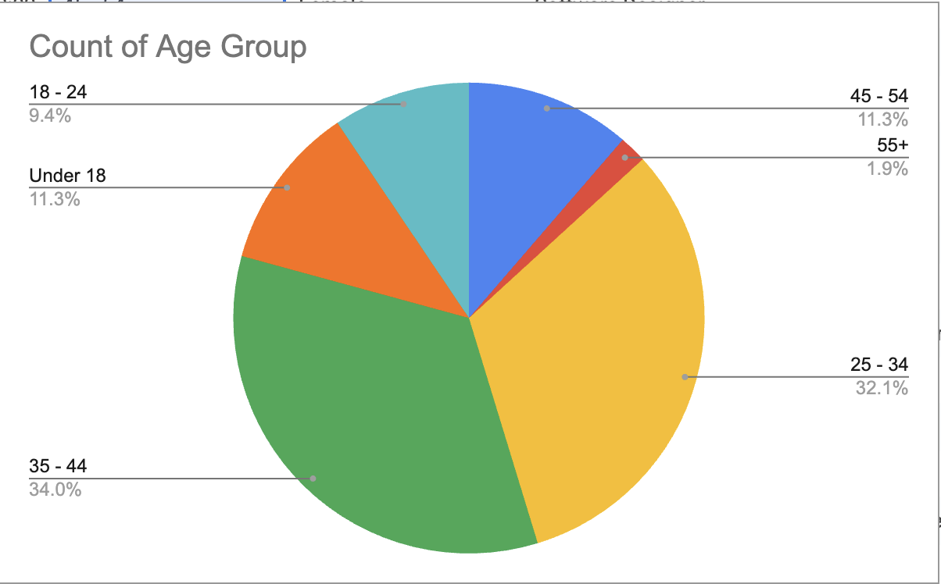

Figure 3 - Age Group

**For Cyclists:**

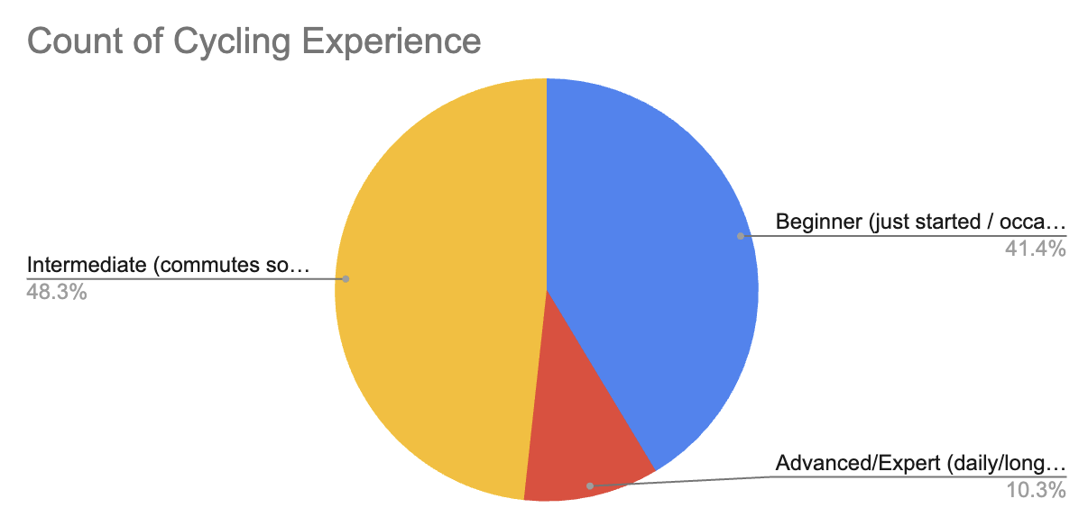

Figure 4 - Cycling Experience

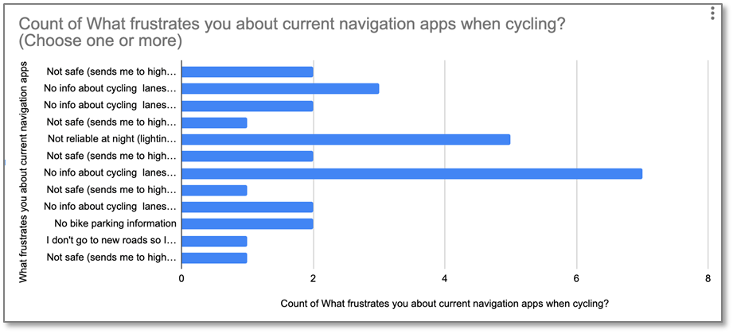

Figure 5 - Current Navigation App Experience for Cyclists

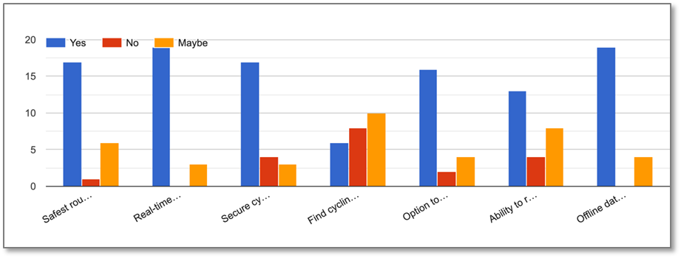

Figure 6 - App Features Rating - Cyclist

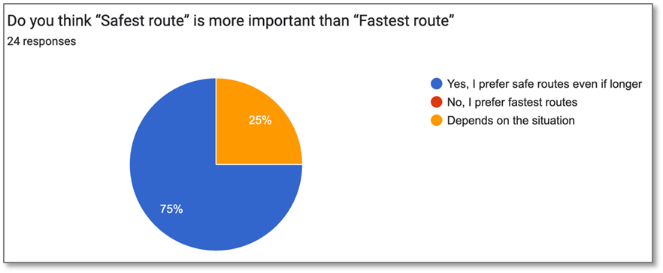

Figure 7 - Fastest vs Safest

**For Pedestrians:**

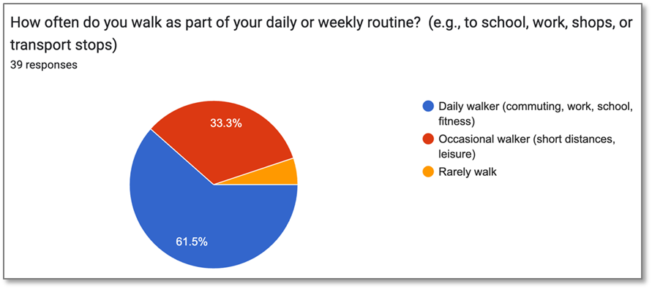

Figure 8 - Walking Experience

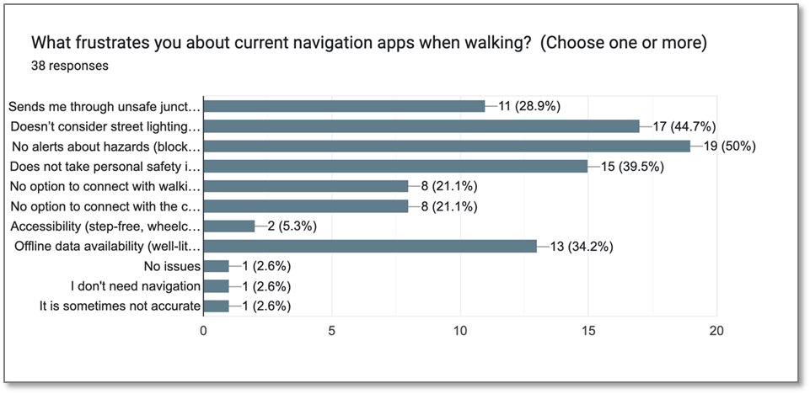

Figure 9 - Current Navigation App Experience for Walkers

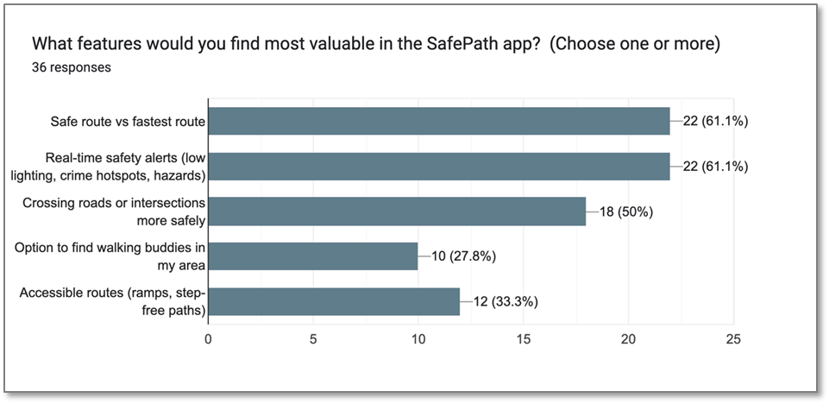

Figure 10 - App Features Rating - Walkers

**For all users ( Cyclist & Pedestrians)**

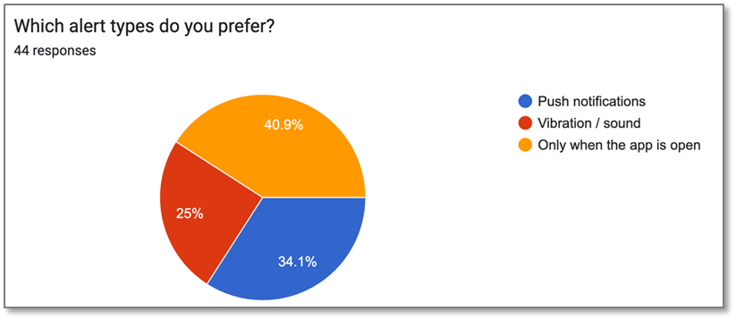

Figure 11 - App Alerts

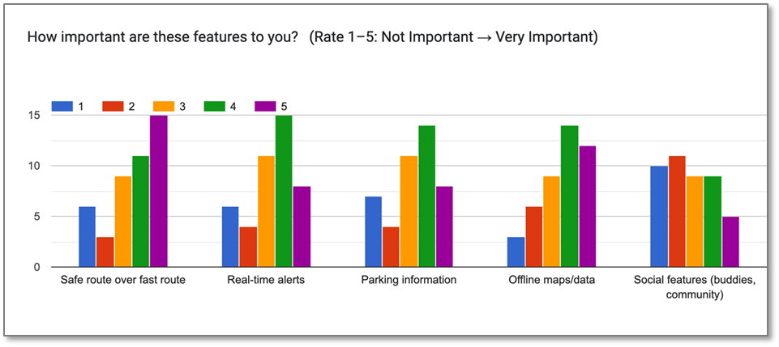

Figure 12 - App Features Rating

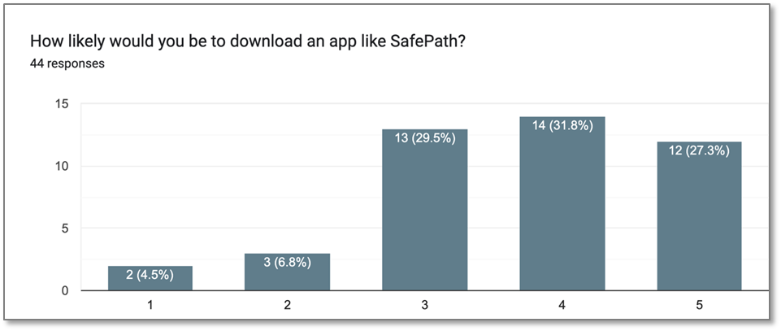

Figure 13 - App Download

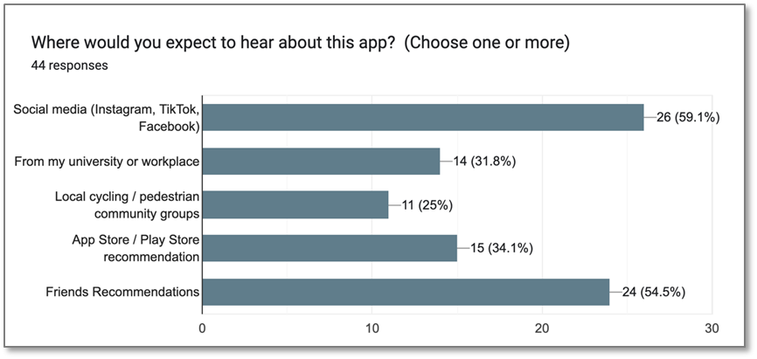

Figure 14 - App Announcement

## User Personas

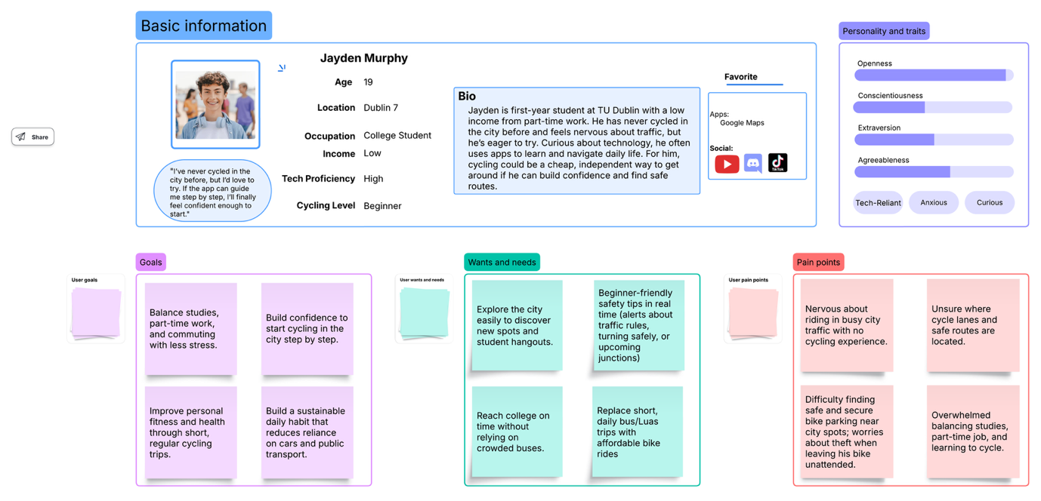

Figure 15 - Beginner Cyclist

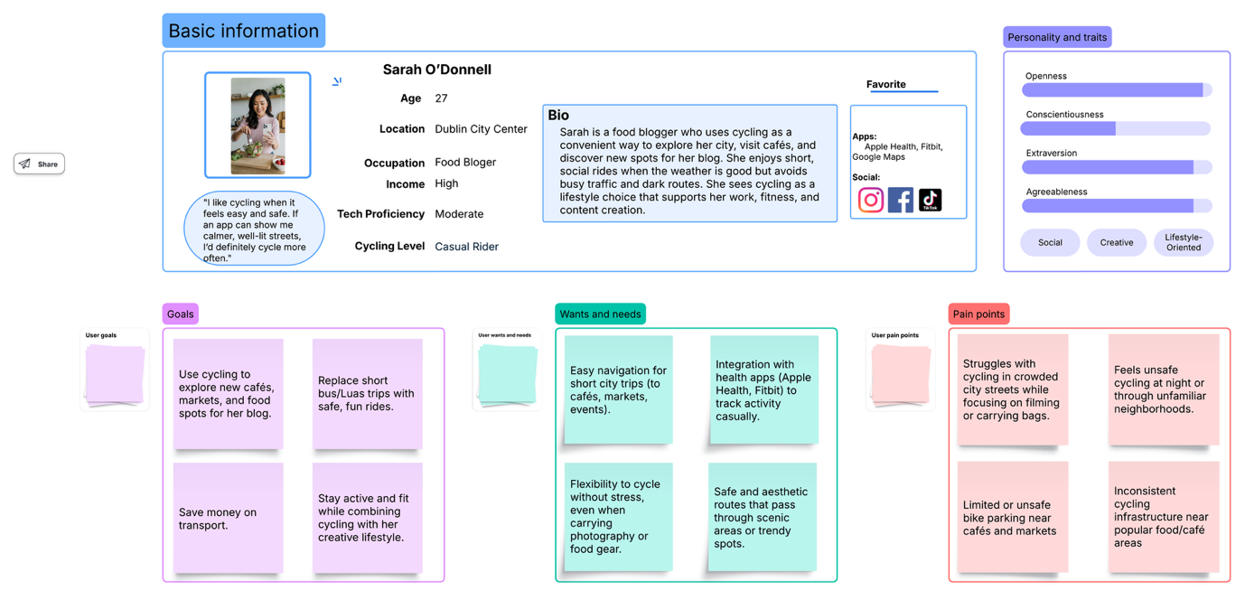

Figure 16 - Casual Cyclist

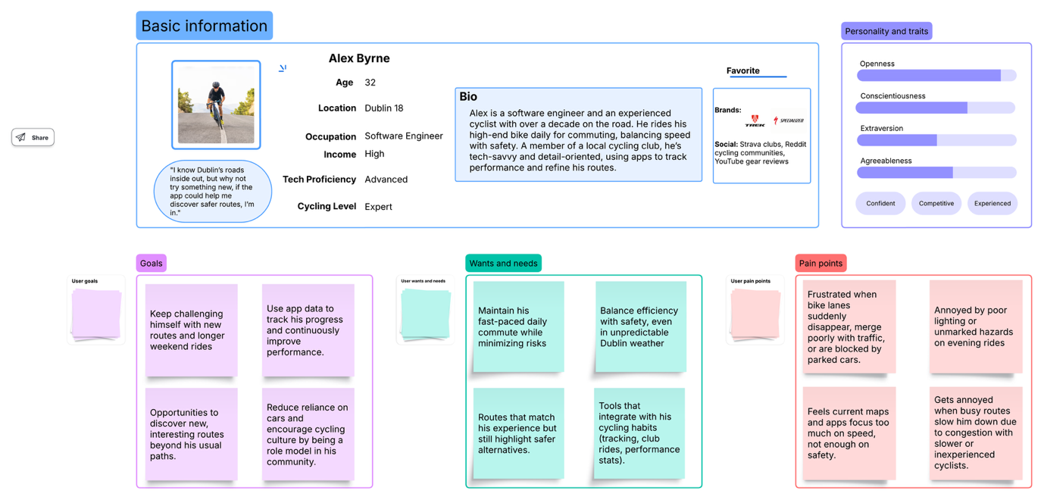

Figure 17 - Expert Cyclist

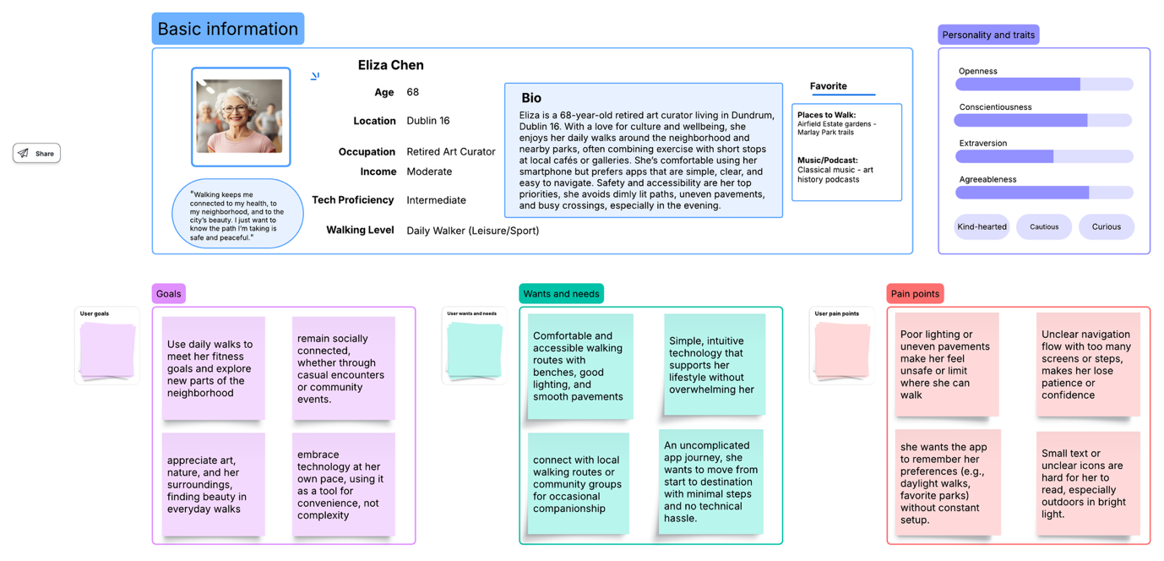

Figure 18 - Daily Walker

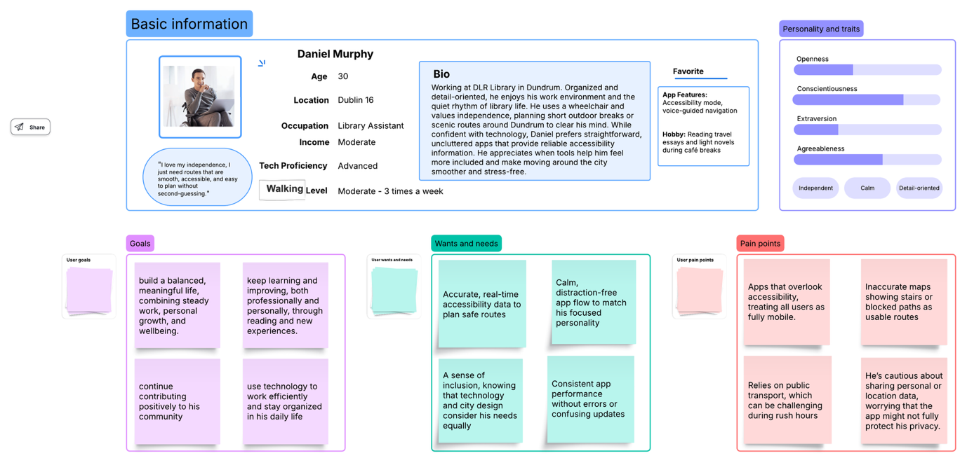

Figure 19 - Accessibility User (Wheelchair)

## Low-Fidelity Screens

**Screen 1&2**

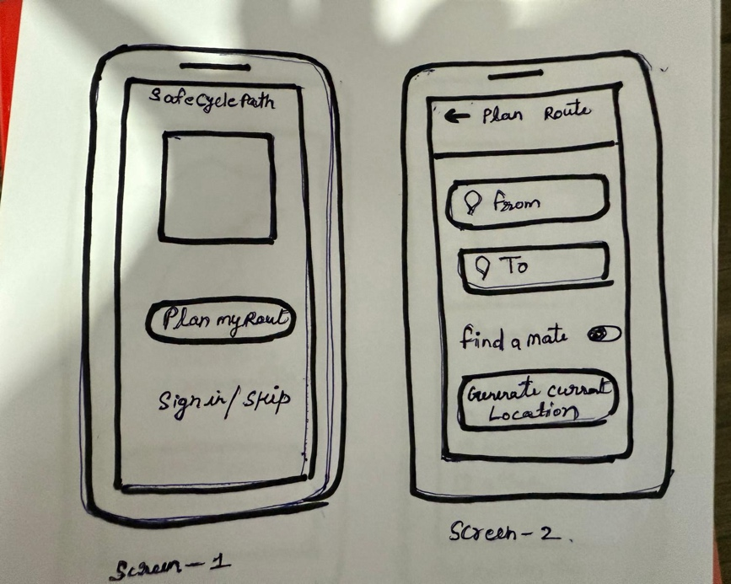

Figure 20 - Landing Page & Plan Route

**Screen 3&4**

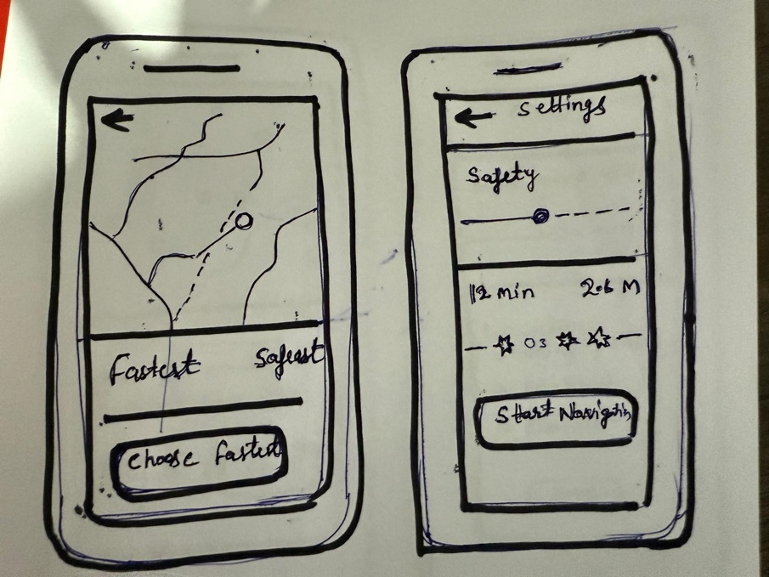

Figure 21 – Route Comparison & User Safety Preference

**Screen 5&6**

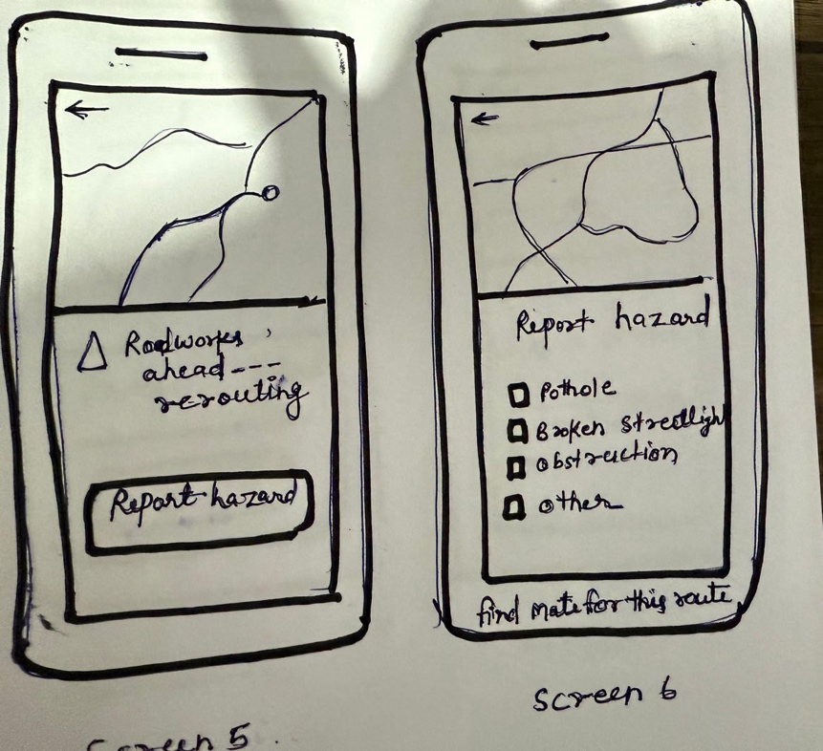

Figure 22 - Report Hazards

**Screen 7&8**

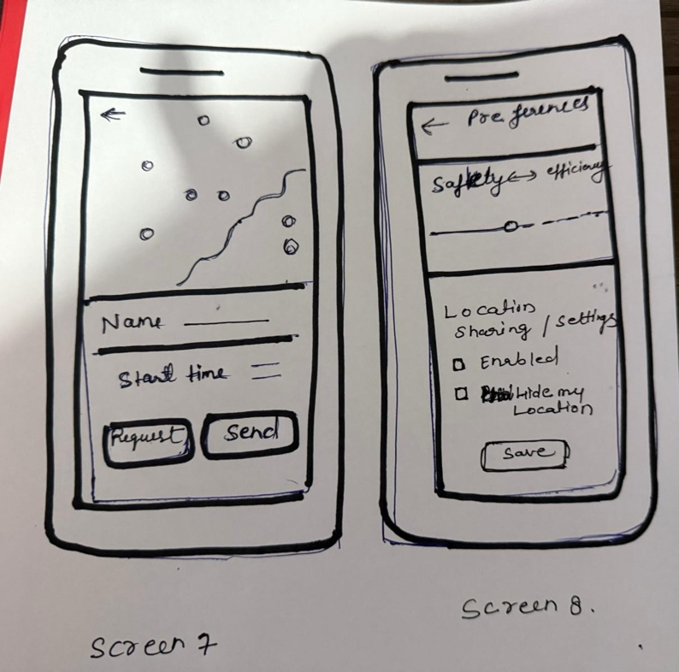

Figure 23 - FindBuddy & User Preferences / Privacy

## Wireframe Screens

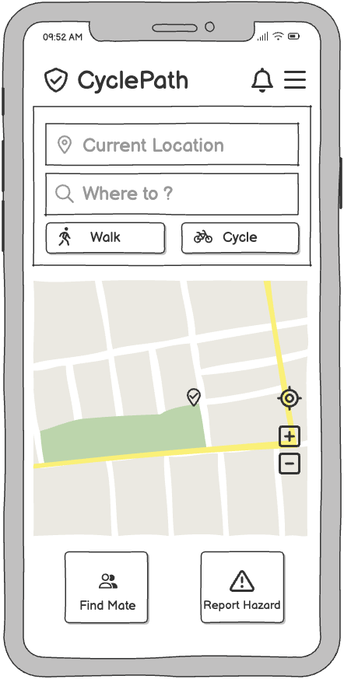

Figure 24 - Home Page

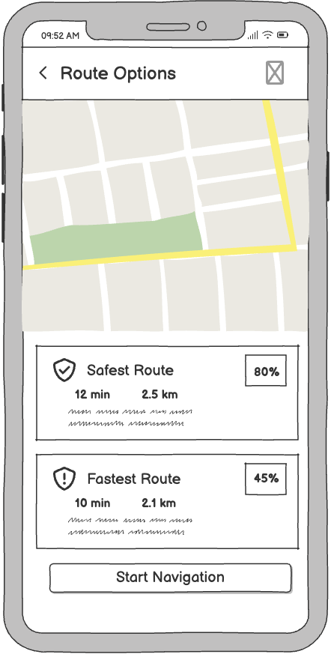

Figure 25 - Suggested Routes

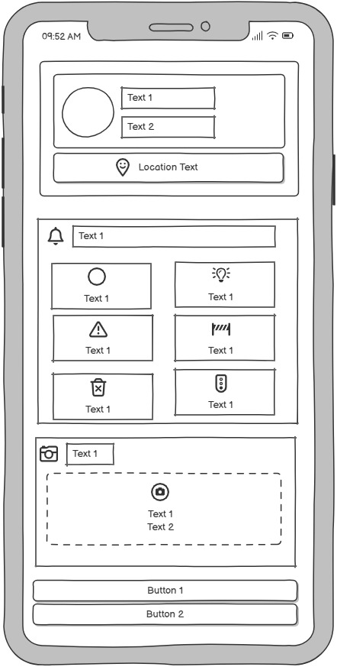

Figure 26 - Report Hazards

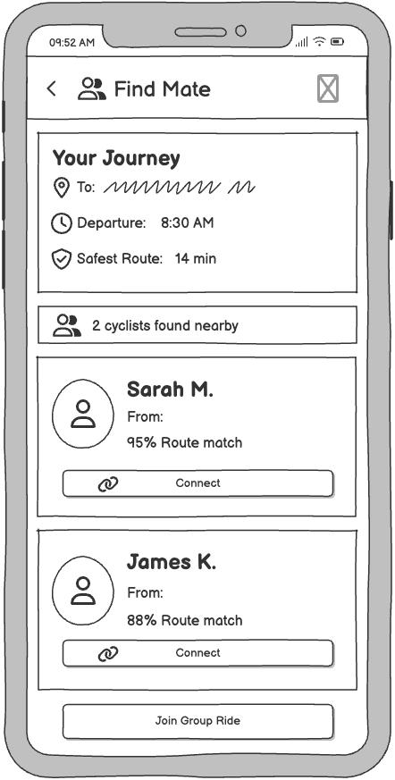

Figure 27 - Find Buddy

## ****Initial Screens -**** Medium-Fidelity

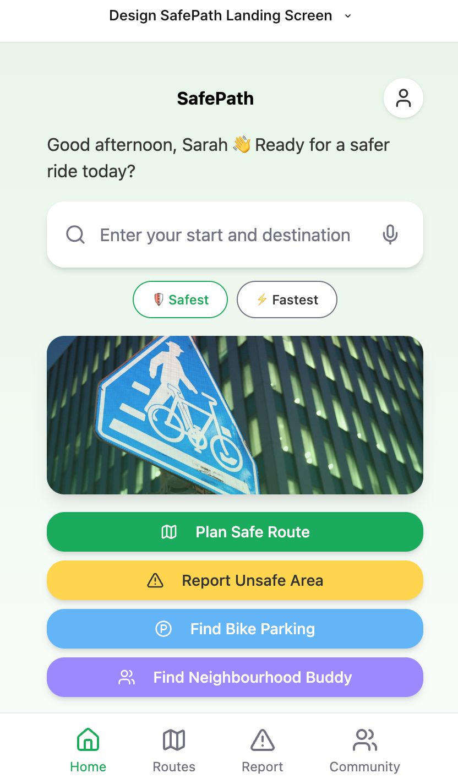

Figure 28 - Landing Page

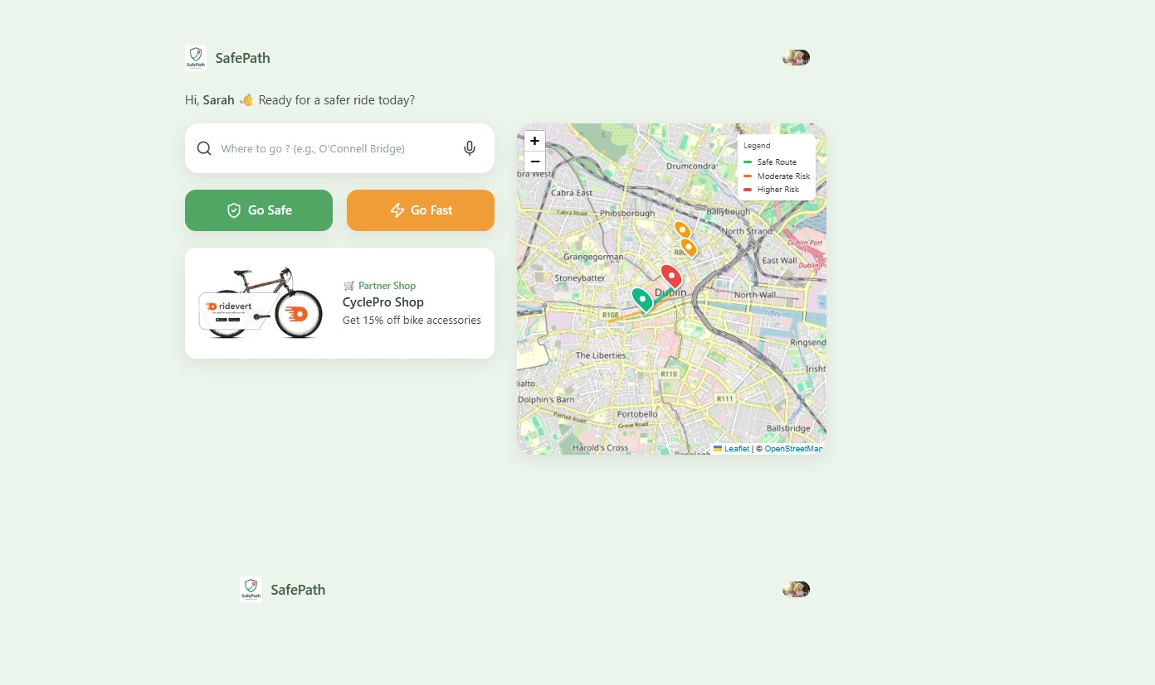

Figure 29 - Landing Page Desktop

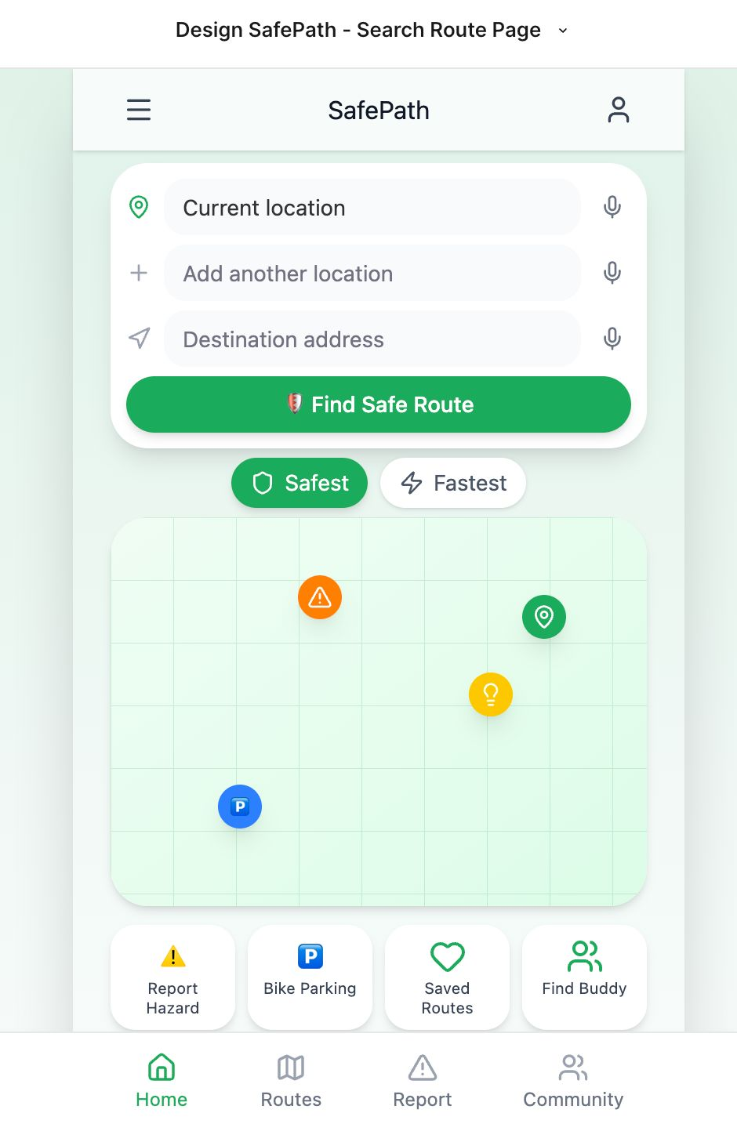

Figure 30 - Find Route

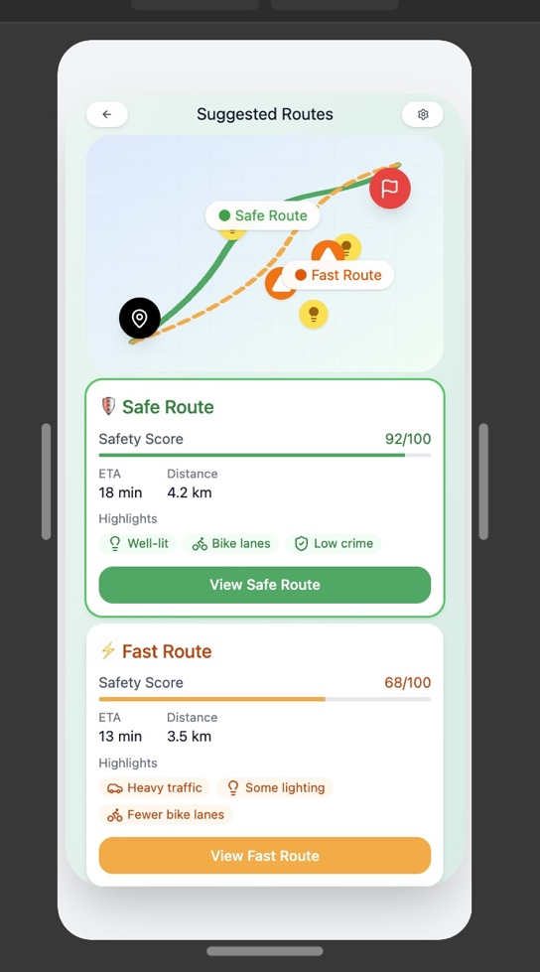

Figure 31 - Suggested Routes

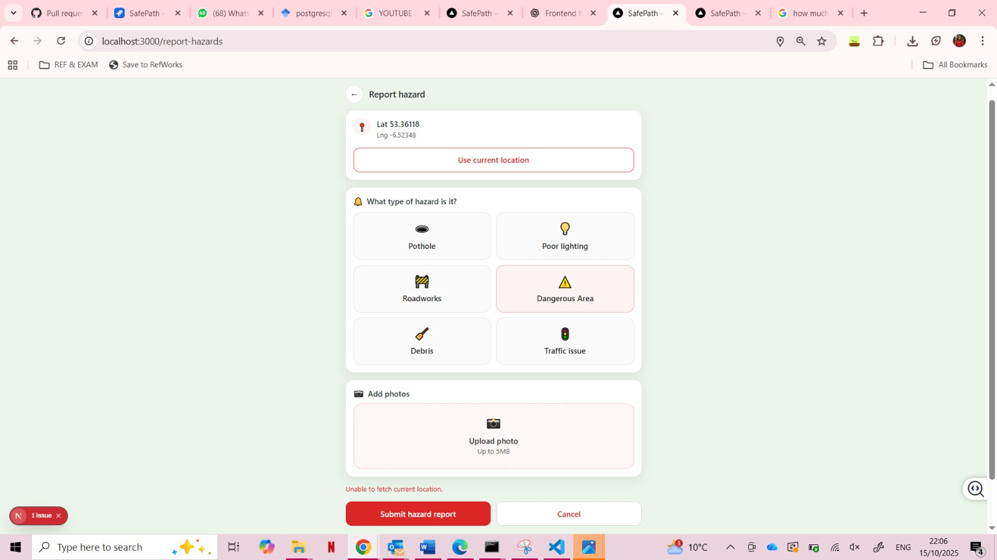

Figure 32 - Report Hazards Desktop

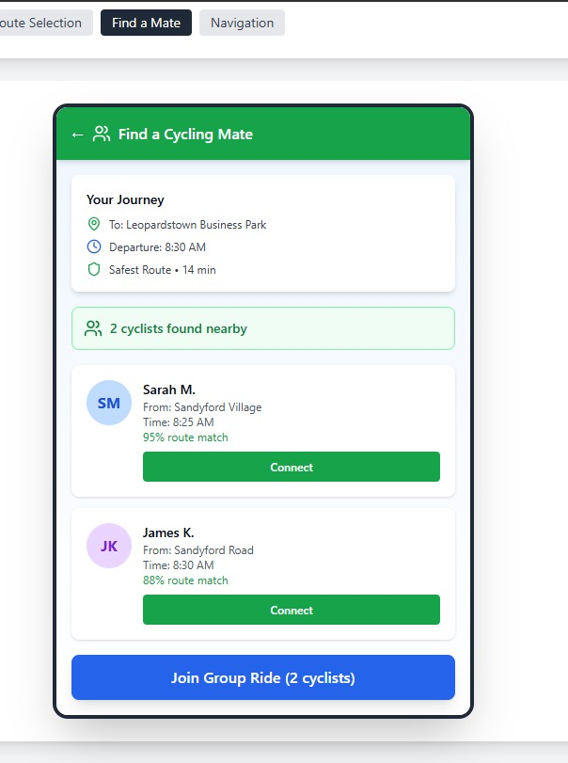

Figure 33 - Find Buddy

## ****Final Application****

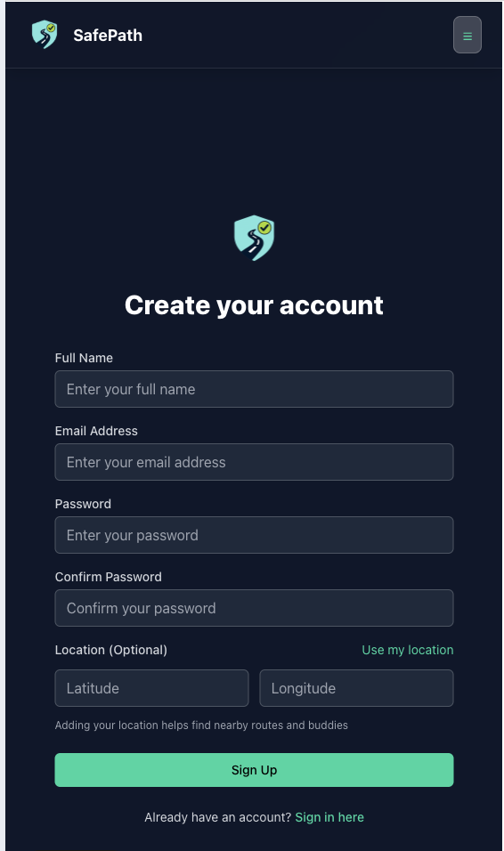

Figure 34 - Sign up Page

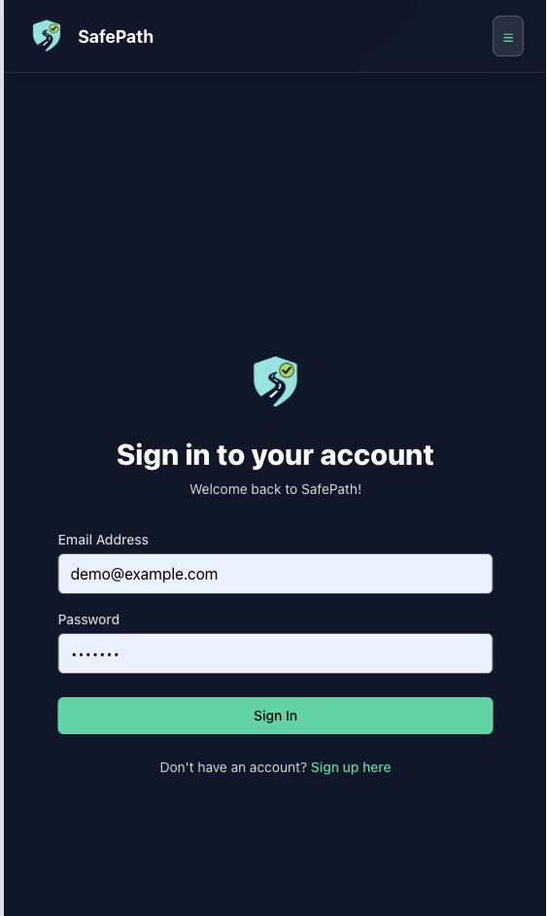

Figure 35 - Login Page

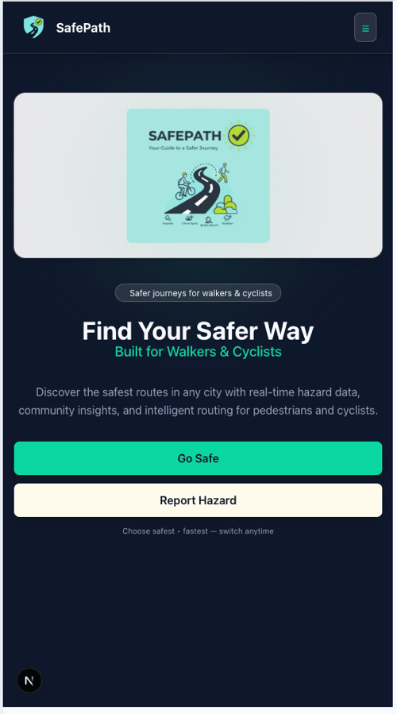

Figure 36 - Home Page

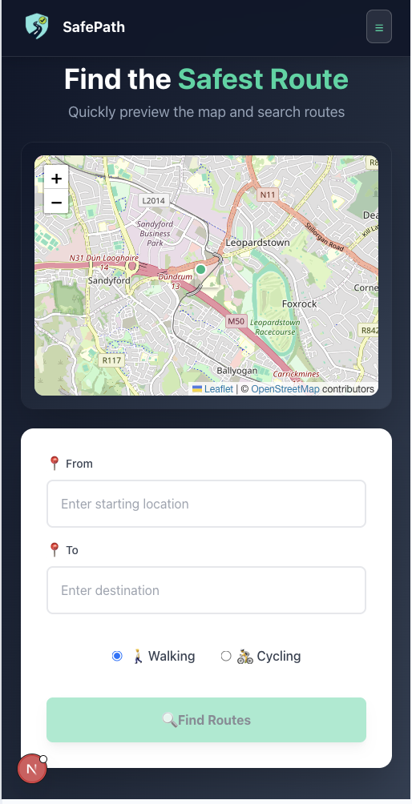

Figure 37 - Suggested Routes

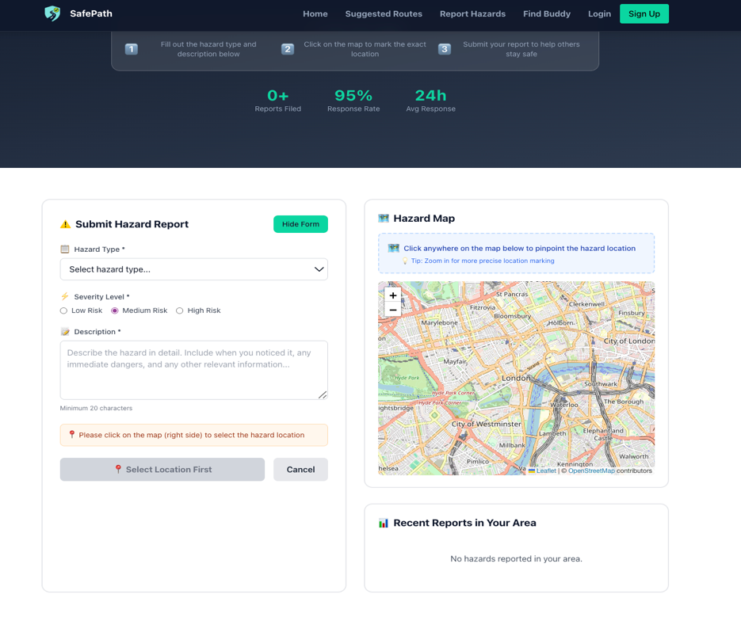

Figure 38- Report Hazards

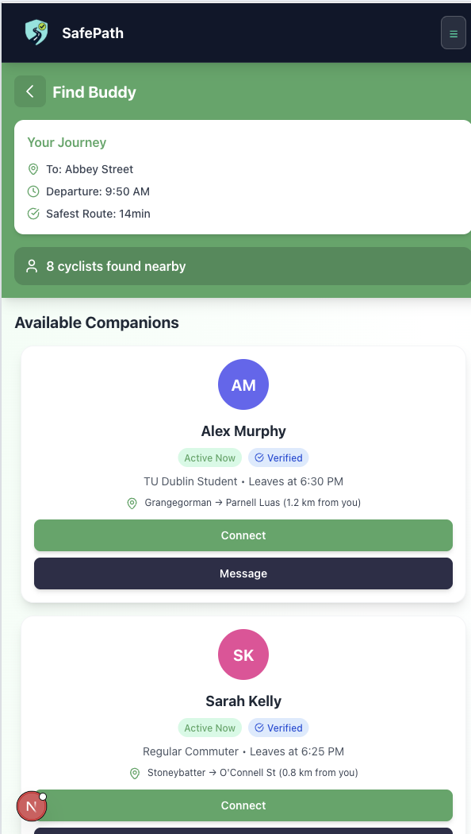

Figure 39 - Find Buddy

## ****Color Analysis & Theme Evolution****

### Logo Design

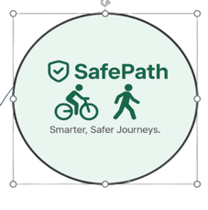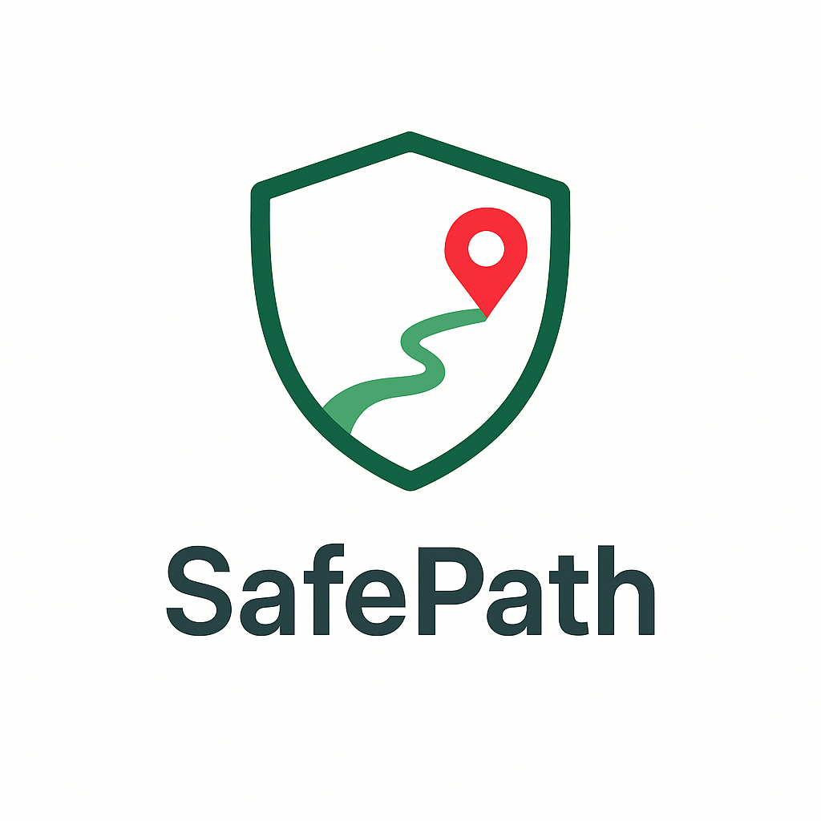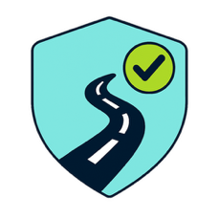

Figure 40 - Logo A

Figure 41 - Logo C

Figure 42 - Logo B

## UI User Research & Insights- Interview Questions

**(Interview- 1)**

* Mode of Interview:
* Gender:
* Age:
* Pedestrian/Cyclist:
* Disabled:
* Education Level

1. What was your first impression when you launched the SafePath app?
2. How would you describe the overall look and feel of the interface (e.g., clean, confusing, cluttered, and simple)?
3. In the first few seconds, did you understand what SafePath is for? Why or why not?
4. How quickly could you locate the core features you needed from the app? Which did you try?
5. Were there any screens where you felt lost or unsure what to do next?
6. Did the labels match what you thought each action would do? Note any mismatches?
7. What’s your impression of the SafePath logo?
8. How well does the logo communicate the app’s purpose?
9. How clear and readable did the UI feel (contrast, text size, map labels, icons)?
10. Were any texts, map elements, or icons hard to read or distinguish? Which ones?
11. How consistent do the visual elements (buttons, maps, icons) feel across the app?
12. Did you find the colour scheme and visuals supportive of the app’s theme? In what ways do the colors and visuals communicate ‘safety’ to you?”
13. How smooth was the process of finding or viewing a route?
14. Were there any delays, confusing steps, or points of frustration?
15. How easy would it be to use this app while walking or cycling?
16. What specific features or information would increase your sense of safety in SafePath and why?
17. What did you expect from a navigation app that you didn’t find in SafePath?
18. What’s your impression of the ‘Find Buddy’ feature? what did you expect it to do? how clearly does it communicate that it helps you find cycling or walking partners? Any suggestions?
19. How likely are you to use this app regularly? Why or why not?

## UI User Research Feedback

**Interview1:**

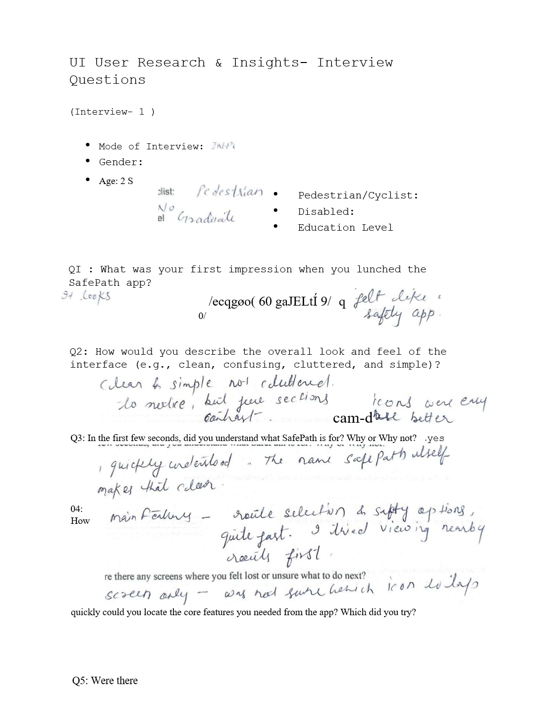

Figure 43 - Interview 1 part a

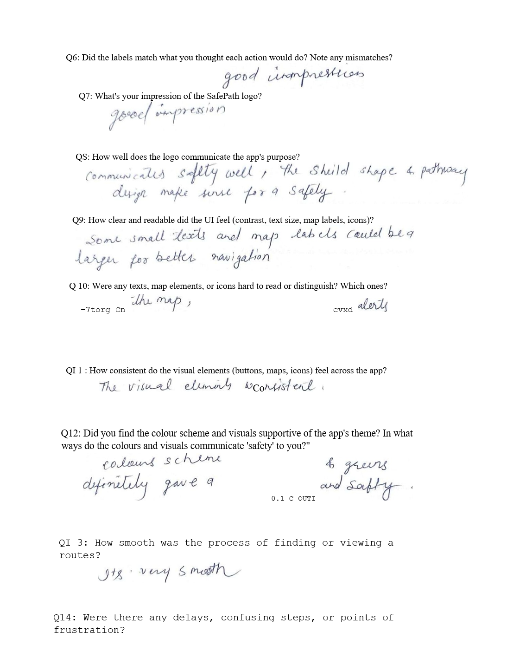

Figure 44 - Interview part b

Figure 45 - Interview 1 part c

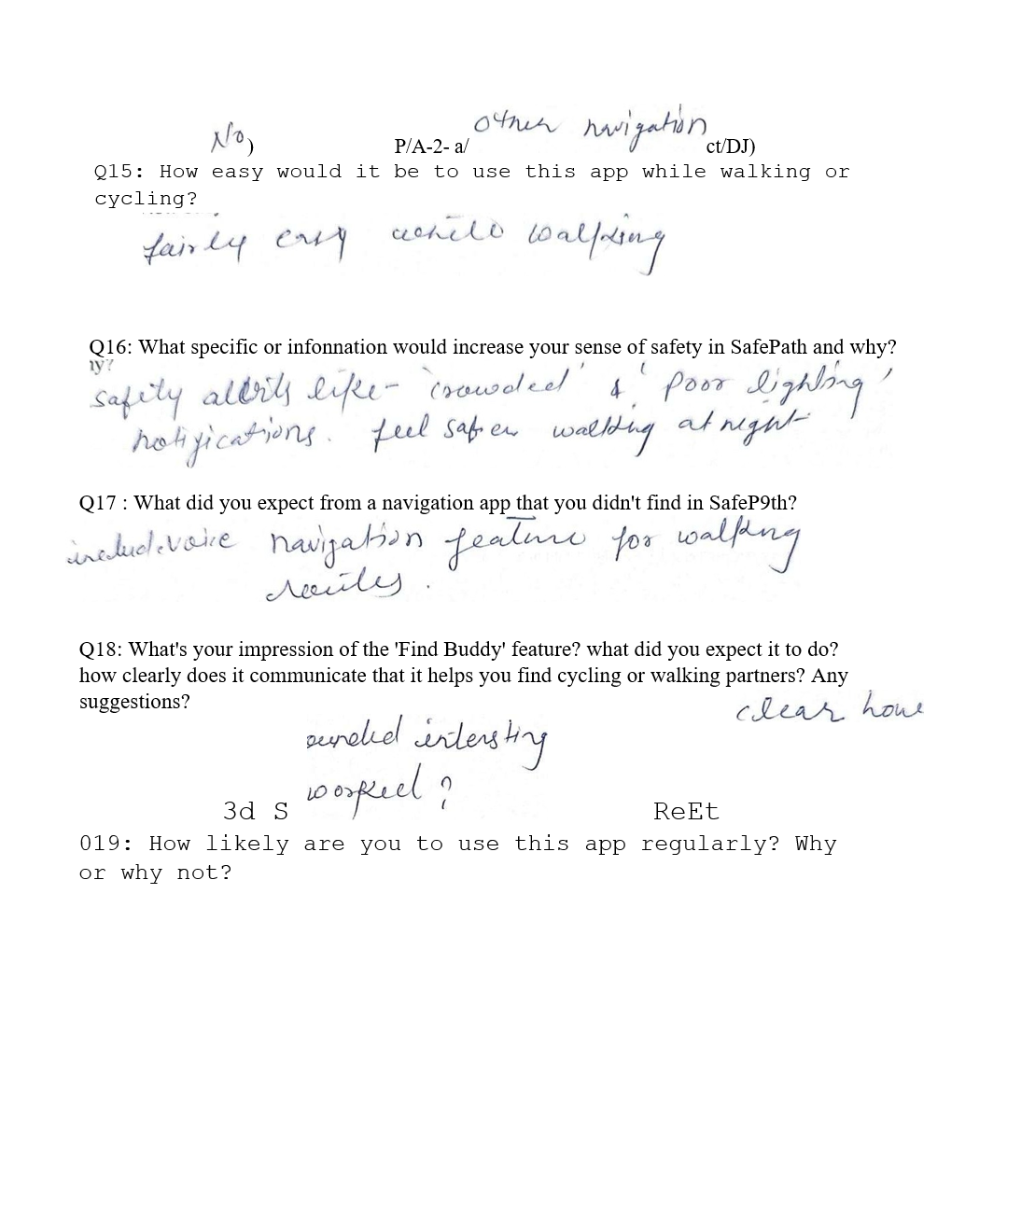

**Interview 2:**

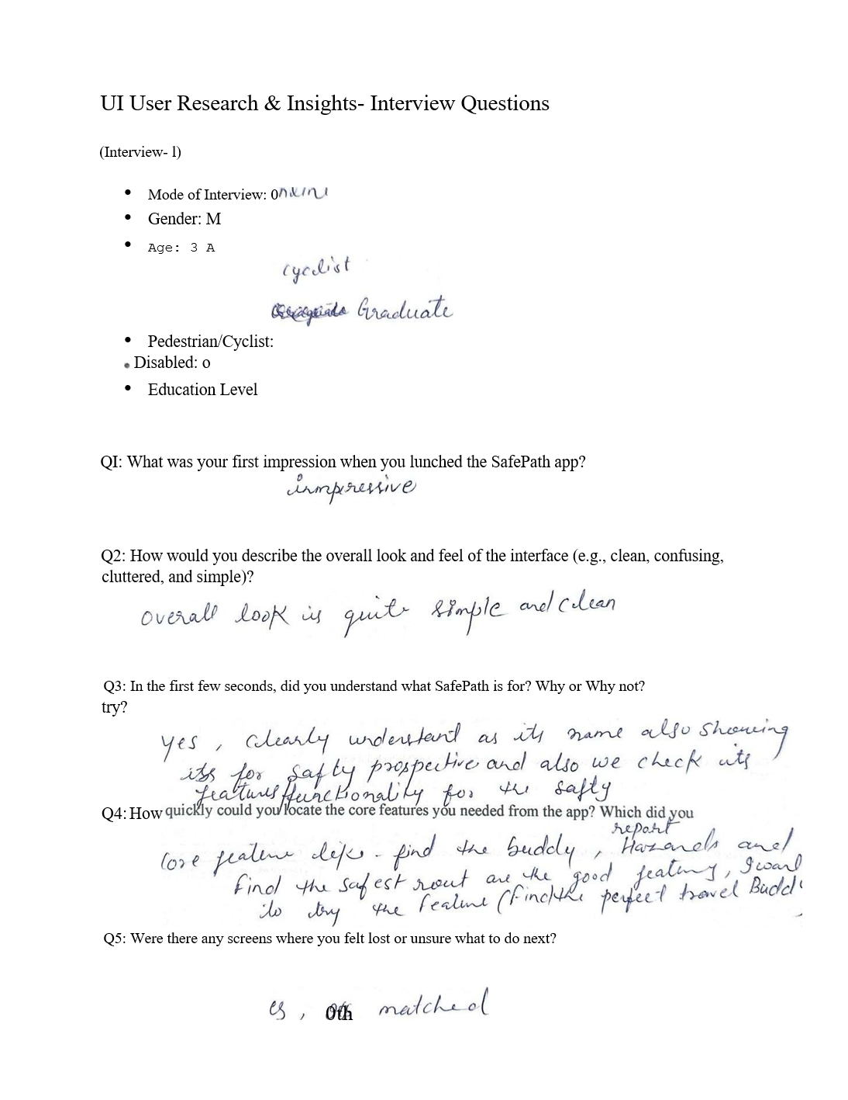

Figure 46 - Interview 2-part a

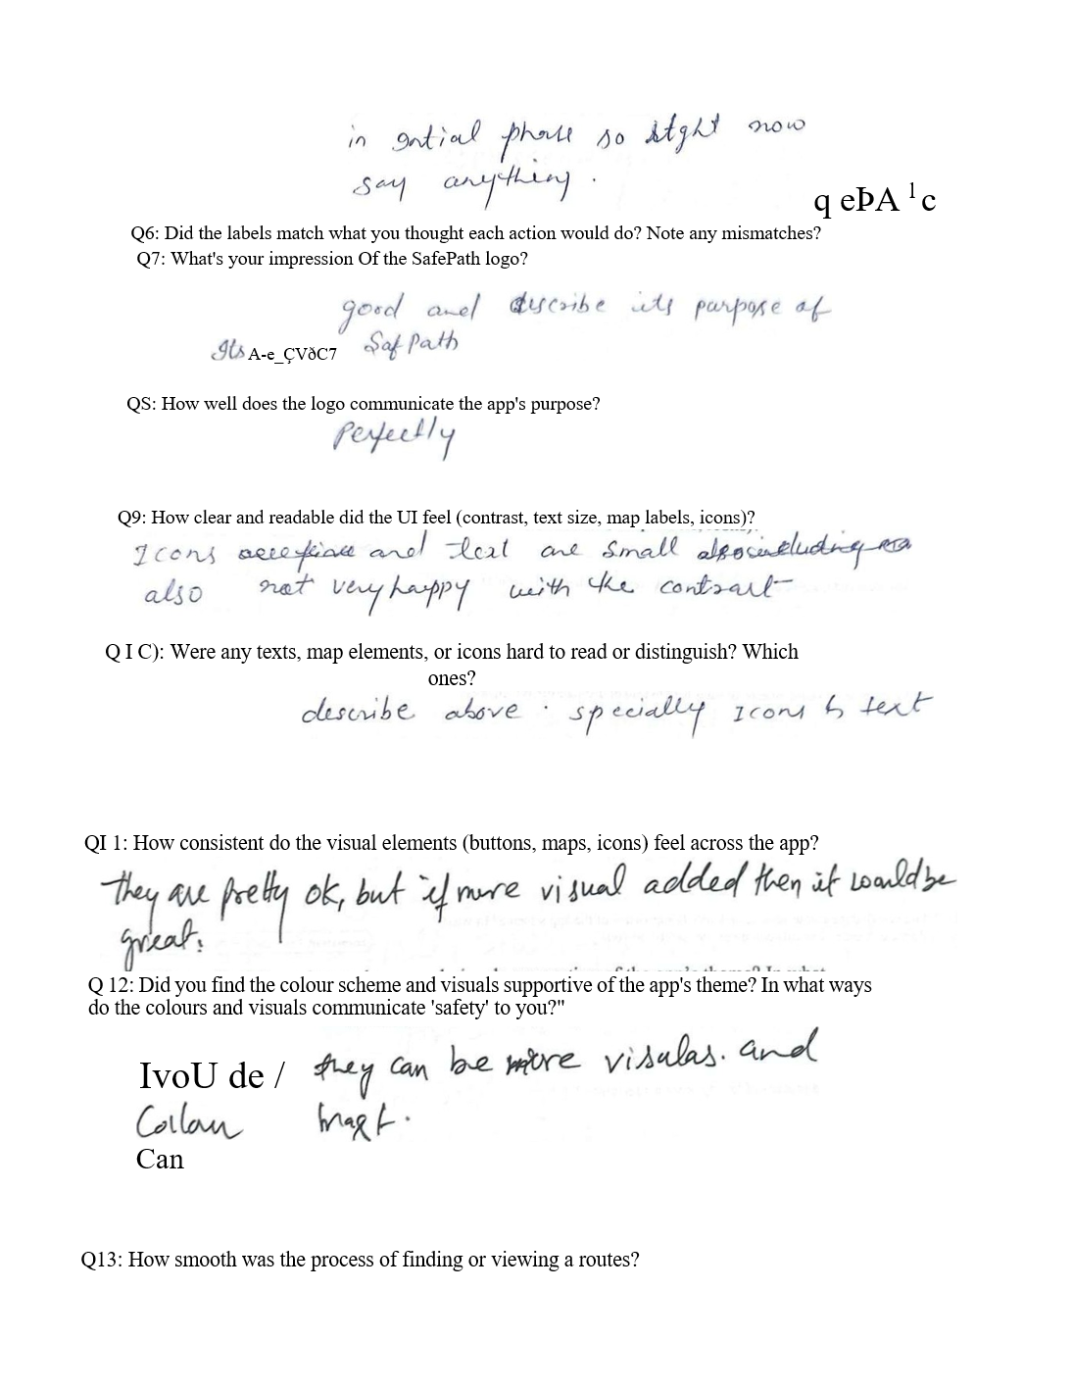

Figure 47 - Interview 2-part b

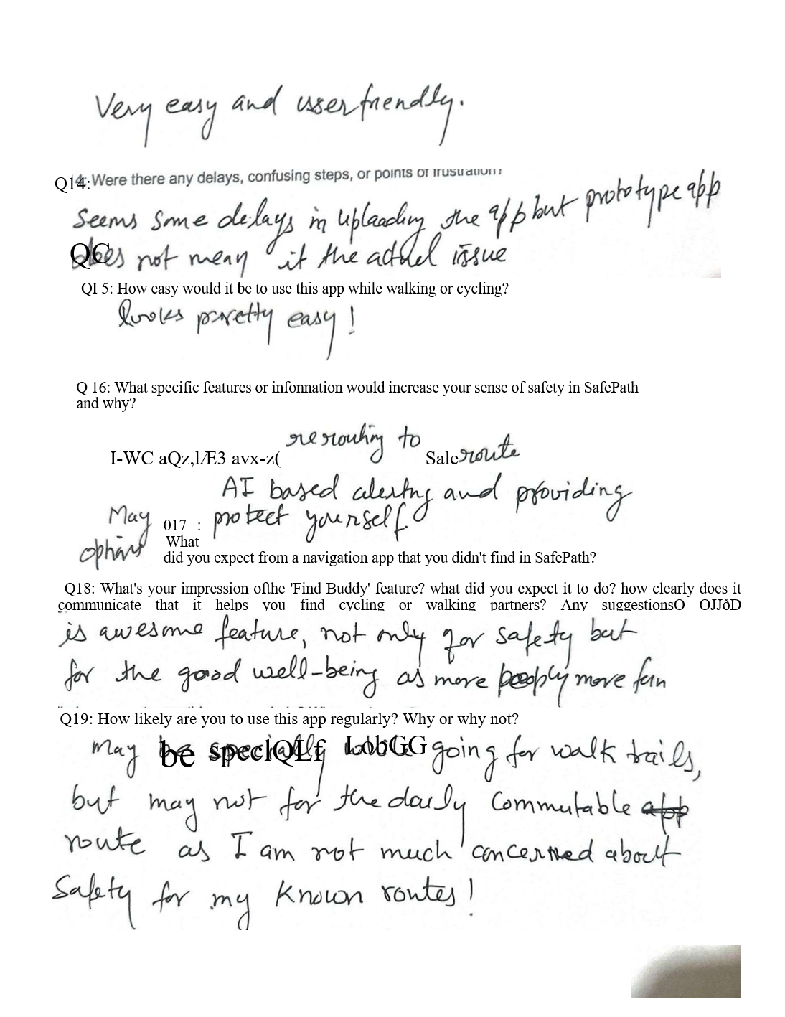

Figure 48 - Interview 2-part c

**Interview 3:**

**Interviewer Details**

* **Name:** Mai
* **Age:** 44
* **Living in:** Dublin
* **Background:** Holds a Master’s degree in Digital Marketing
* **Lifestyle:** Walks daily to track steps; health-conscious; prefers walking over driving when the area is mostly safe and clean.
* **Personality:** Very organized, structured, and detail-oriented; notices small inconsistencies; calm but a keen critic.
* **Tech comfort:** Comfortable with mobile apps, especially ones with clean UI and clear purpose. Expects professional-level UX.
* **Goals with SafePath:**
  + Find the safest, cleanest, best-lit routes for walking.
  + Avoid unsafe or crowded areas.
  + Feel secure before going out alone.
  + Maybe share safe routes with friends/family.
* **Pain points / concerns:**
  + Vague or cluttered interfaces.
  + Maps that don’t explain *why* a route is “safe.”
  + Low contrast/small text (she likes readable UI).
  + Features that are there but not clearly explained (e.g. “Find Buddy”).
* **Motivation to use:** If the app actually helps her feel safer and gives her control (choose safer vs faster), she will use it regularly.

**Interview Setup**The interview was conducted in person in the lounge area of my apartment. This setting was chosen because it was quiet, comfortable, and allowed her to focus on the interface without distractions.

**Device & Version Tested**  
She tested the SafePath web app on my laptop. I explained to her that the app is still in development and that some pages are prototypes or partially working.

**What Interviewer Test**

1. **Suggested Routes page (in-progress):**
   * I asked her to enter a **From** and **To** point.
   * Then she clicked **“Suggested Routes”** to see how the app would display safer options.
   * I told her this page is still under construction, so some data/labels might not be final.
2. **Profile page:**
   * I showed her where, in the future, users can adjust safety preferences (e.g. prioritising safer streets, lighting, personalisation).
3. **Find Buddy page (prototype):**
   * I walked her through the idea of finding a walking/cycling partner.
   * I explained it’s not fully functional yet, and I wanted to know if the concept was clear.
4. **Hazards page (prototype):**
   * I showed her how reported hazards would appear on the map.
   * I asked if the icons and colours were understandable.

**Context Interviewer Mentioned**

* She said she walks a lot in Dublin but doesn’t like to go out in **heavy rain**, so routes that are short/safe are important to her in winter.
* Because she is detail-oriented, I specifically asked her to comment on wording, icons, and colours.

**Interview Q & A:**

This dialogue was extracted from the recorded usability interview session with Mai. Minor edits were made for readability.

1. **What was your first impression when you launched the SafePath app?**

it looks like a maps app but a bit different. I could tell it’s not just for directions, something about safety. But I needed a second to know what to click.

1. **How would you describe the overall look and feel of the interface (e.g., clean, confusing, cluttered, and simple)?**

It’s fairly clean, not messy. Some parts look like they’re still being worked on. The map is clear though.

1. **In the first few seconds, did you understand what SafePath is for? Why or why not?**

Kind of. I understood it helps me pick a safer route, which I like because I walk a lot here in Dublin. But I wasn’t 100% sure how you decide what is safe.

1. **How quickly could you locate the core features you needed from the app? Which did you try?**

I found the start/end part quickly. That’s familiar. I tried to see the routes and the safety bits. I saw a buddy thing but didn’t touch it first.

1. **Were there any screens where you felt lost or unsure what to do next?**

Yes, when the map started showing extra icons. I didn’t know what each one meant straight away.

1. **Did the labels match what you thought each action would do? Note any mismatches?**

Mostly, yes. But for safety things, I prefer clearer wording. Like ‘safer route’ instead of just ‘suggested.

1. **What’s your impression of the SafePath logo?**

It’s nice, I like that it looks like protection. Maybe could be a bit more modern.

1. **How well does the logo communicate the app’s purpose?**

Not on its own. If I saw only the logo, I wouldn’t know it’s about safe walking/cycling. With the name, yes.

1. **How clear and readable did the UI feel (contrast, text size, map labels, icons)?**

Text is okay. On the map, some things could be bigger, especially if I’m outside and it’s grey weather, which is a lot in Dublin.

1. **Were any texts, map elements, or icons hard to read or distinguish? Which ones?**

The small icons on the map and the colours that are too close. If it’s raining and I’m checking quickly, I need it very clear.

1. **How consistent do the visual elements (buttons, maps, icons) feel across the app?**

It’s mostly consistent, but I noticed a few buttons that don’t look the same. I notice small things like that.

1. **Did you find the color scheme and visuals supportive of the app’s theme? In what ways do the colors and visuals communicate ‘safety’ to you?**

Yeah, the colours are calm, which I like. If you use red/orange only for danger, that helps. Safety should look calm, not stressful.

1. **How smooth was the process of finding or viewing a route?**

It worked, but I wanted it a bit faster like: I enter 2 places I instantly see 3 options (safe / normal / fast).

1. **Were there any delays, confusing steps, or points of frustration?**

The confusing part is not knowing why this route is safer. If it tells me better lit or less crime, I’ll trust it more.

1. **How easy would it be to use this app while walking or cycling?**

Walking yes, if the buttons are big. Cycling harder. I wouldn’t tap too much while cycling. I’d prefer voice or very clear line.

1. **What specific features or information would increase your sense of safety in SafePath and why?**
   * Show me streets that are well lit, especially in winter.
   * Let me avoid certain areas at night.
   * Weather-aware would be great, I don’t like walking in heavy rain, so if it tells me shorter but safe that day, I’d take it.
   * Share my route with someone.
2. **What did you expect from a navigation app that you didn’t find in SafePath?**

I expected something like start navigation with steps. And maybe recent reports, like someone reported this area.

1. **What’s your impression of the ‘Find Buddy’ feature? what did you expect it to do? how clearly does it communicate that it helps you find cycling or walking partners? Any suggestions?**

I like the idea, especially for women. But I wasn’t sure: is it for my friends or random people nearby? If it’s for trusted people, say that. If it’s public, I want control.

1. **How likely are you to use this app regularly? Why or why not?**

If it really shows safer streets in Dublin, especially dark/rainy evenings, I would. If it’s just a normal map, I’ll just use Google Maps.

**Interview 4:**

**Interviewer Details**

* **Name:** Yassin
* **Age:** 17
* **Living in:** Dublin
* **Background:** Secondary School Student
* **Lifestyle:** Walks daily to school and to basketball training; cycles sometimes for fun/weekends; active and sporty.
* **Personality:** Easy-going and straightforward; not very detail-obsessed; notices obvious usability issues (too many steps, slow responses) more than small visual inconsistencies.
* **Tech comfort:** Very comfortable with mobile and web apps; expects things to be fast and simple like other apps he uses; prefers minimal steps.
* **Goals with SafePath:**
  + Find a safe/easy route to school or training.
  + See which routes are better for cycling.
  + Avoid dark areas, especially in winter.
  + Be able to share or show the route to family/friends.
* **Pain points / concerns:**
  + Too many steps or scrolling after selecting a route.
  + Not clear why one route is safer.
  + Buttons or results not visible straight away.
* **Motivation to use:** If the app gives him safer or smarter routes than Google Maps, especially for walking/cycling around Dublin, and shows results quickly, he will use it. If it feels slow or the same as normal maps, he won’t.

**Interview Setup**The interview was conducted in person in the lounge area of my apartment. This setting was chosen because it was quiet, comfortable, and allowed interviewer to focus on the interface without distractions.

**Device & Version Tested**  
H tested the SafePath web app on my laptop. I explained to him that the app is still in development and that some pages are prototypes or partially working.

**What Interviewer Test**

1. **Suggested Routes page (in-progress):**
   * I asked him to enter a **From** and **To** point.
   * Then she clicked **“Suggested Routes”** to see how the app would display safer options.
   * I told him this page is still under construction, so some data/labels might not be final.
2. **Profile page:**
   * I showed him where, in the future, users can adjust safety preferences (e.g. prioritising safer streets, lighting, personalisation).
3. **Find Buddy page (prototype):**
   * I walked him through the idea of finding a walking/cycling partner.
   * I explained it’s not fully functional yet, and I wanted to know if the concept was clear.
4. **Hazards page (prototype):**
   * I showed him how reported hazards would appear on the map.
   * I asked if the icons and colours were understandable.

**Context Interviewer Mentioned**

* He said he prefers something that combines **fast and safe** in a smart way
* Because he sometimes cycles, he wants the app to be **very easy to use while moving**, not too many steps, not too many buttons.
* When I explained the **Find Buddy** feature, he liked the idea, especially if it’s with people he already knows (friends/relatives).

**Interview Q & A:**

This dialogue was extracted from the recorded usability interview session with Mai. Minor edits were made for readability.

1. **What was your first impression when you launched the SafePath app?**

Yeah, it looks like a map’s thing. I could see it’s not just normal directions like it’s for safety. I just wasn’t sure where to start.

1. **How would you describe the overall look and feel of the interface (e.g., clean, confusing, cluttered, and simple)?**

It’s grand. Kinda clean. Some parts look like you’re still making it. Map is fine.

1. **In the first few seconds, did you understand what SafePath is for? Why or why not?**

Mostly, yeah. Like, safer routes. I just didn’t know how it knows it’s safe.

1. **How quickly could you locate the core features you needed from the app? Which did you try?**

Everything was clear in the menu. I saw the main stuff. I couldn’t try all of it because some parts weren’t ready, so I mainly used the suggested routes page.

1. **Were there any screens where you felt lost or unsure what to do next?**

On mobile it was a bit annoying. I had to scroll down to see the results. Mobile view needs to be easier.

1. **Did the labels match what you thought each action would do? Note any mismatches?**

Yeah, they made sense.

1. **What’s your impression of the SafePath logo?**

Looks cool.

1. **How well does the logo communicate the app’s purpose?**

Kinda. With the name, yeah.

1. **How clear and readable did the UI feel (contrast, text size, map labels, icons)?**

I could read everything. Just on mobile it needs some fixes to be smoother.

1. **Were any texts, map elements, or icons hard to read or distinguish? Which ones?**

Not really. Just the bottom/footer part that could look more like other apps with bottom menu.

1. **How consistent do the visual elements (buttons, maps, icons) feel across the app?**

Mostly the same.

1. **Did you find the color scheme and visuals supportive of the app’s theme? In what ways do the colors and visuals communicate ‘safety’ to you?**

Yeah, colours are fine. If red is only for danger that’s good.

1. **How smooth was the process of finding or viewing a route?**

It worked. I’d prefer it a bit faster, like 70% fast, 30% safe.

1. **Were there any delays, confusing steps, or points of frustration?**

Just not knowing why it’s safer. If it showed ‘better lit’ or ‘less traffic’ I’d get it.

1. **How easy would it be to use this app while walking or cycling?**

Walking no problem. Cycling I don’t wanna press too much. Just start and follow.

1. **What specific features or information would increase your sense of safety in SafePath and why?**

* Show if the road is busy.
* Show if it’s dark there.
* Let me share route with my parents.
* Tell me if there’s roadworks/closed roads.

1. **What did you expect from a navigation app that you didn’t find in SafePath?**

I expected like a proper ‘Start’ button with turn-by-turn, not just showing the route. And maybe pop-ups like ‘this road was reported yesterday’ or ‘hazard ahead’. That wasn’t there.

1. **What’s your impression of the ‘Find Buddy’ feature? what did you expect it to do? how clearly does it communicate that it helps you find cycling or walking partners? Any suggestions?**

Cool idea. I’d only use it with people I know, not randoms. So that needs to be clear.

1. **How likely are you to use this app regularly? Why or why not?**

If it gives me better routes specially at night for school/training, yeah. If it’s same as Google, I’ll just use Google.